APUSH
Mr. Turner

Unit Guide: The “Roaring 20’s,” the Great Depression and World War II (Brinkley Ch. 22-26)

Essential Questions:  - How did the 1920s reflect divisions in American society?  - What different factors caused the Great Depression?  - How did the Great Depression and the government’s response change the United States?  - How did “total war” impact both the American homefront and military strategy? | 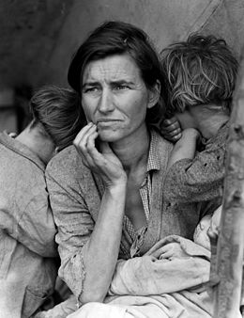

Study Questions
- How did new technologies change the US in the 1920s?
- How was life in urban and rural American different in the 1920s?
- How did nativism influence the US in the 1920s?
- What caused the Great Migration and what were its consequences?
- How did FDR respond to the Depression? To what extent was he successful?
- What were the voices criticizing FDR’s response to the Depression? How did that criticism affect FDR?
- What is the legacy of the New Deal?
- Why did the US shift from isolationism in the 1920s and 30s to eventual involvement in World War II?
- Why did the US use “Total War” strategies during World War II?
- What were the social effects of World War II on the US?

