11 U.S. History A Block
Mr. Bedar

Unit Syllabus: The 1920s and the Great Depression
Essential Questions:
- Why was the 1920s a “decade of contradictions”?
- How did the stock market crash of 1929 relate to the Great Depression?
- How did globalization turn “The Crash of ‘29” into a global financial crisis and worldwide Great Depression?
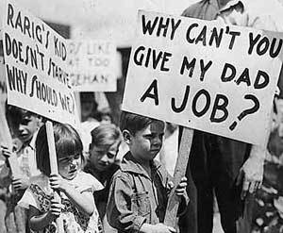
- How were ordinary Americans affected by the Great Depression?
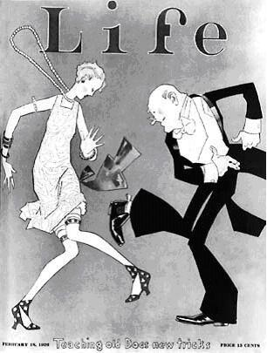
- Why is the New Deal referred to as “The Third American Revolution?”

ID Terms:
Read each assignment carefully & identify the ID terms below in your own words. These will serve as excellent study tools. For each ID term, make sure you are able to A) define/describe (who/what/when/where) and B) explain why it is historically significant.
Assgt. # | Reading/Topic | Date Due | ID Terms
1 | Chapter 20 Section 1: A Booming Economy (p.660—665) |  | Henry Ford  Mass production  Model T  Assembly lines  Impact of automobile | Consumer Rev.  Installment buying  “Bull” market  buying on margin
2 | Chapter 21 Section 1: Causes of the Great Depression (p.702-708) |  | Herbert Hoover  Agricultural problems  Distribution of wealth  “easy credit”  speculation | “Black Tuesday”  business cycle  Great Depression  Hawley-Smoot Tariff
3 | Chapter 21 Section 2: Americans Face Hard Times (p. 709-717) |  | Bread line  Hoovervilles  Dust Bowl | Okies  GD impact on families  GD impact on minorities
4 | Chapter 22 Section 1: FDR Offers Relief and Recovery (p.732-739) |  | FDR’s personal story  New Deal  100 Days  Fireside chats | “Alphabet Soup”: FDIC, AAA, TVA, CCC, NRA, PWA  Attacks on New Deal
5 | Chapter 22 Section 2: The Second New Deal (p. 740-747) |  | Second New Deal: WPA, Social Security  John M. Keynes, “pump priming” | Wagner Act  Collective bargaining  CIO  “court packing”
6 | Chapter 22 Section 3: Effects of the New Deal (p.748-757) |  | Effects on women  Effects on African-Am.  Effects on Native Americans | New Deal Coalition  Expanding role of gov’t  Welfare state  “changing presidency”

