APUSH

Unit Guide: The Antebellum Era, 1840-1860 (Brinkley Ch. 10-13)

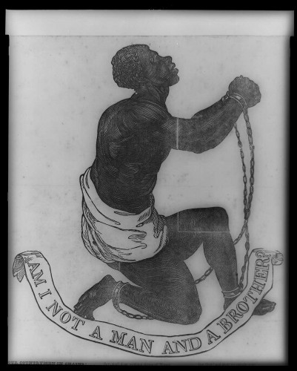

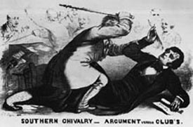
Essential Questions:
- To what extent did sectionalism and industrialization shape the nation during the period 1840-1860?
- How did the Second Great Awakening spur antebellum reform movements?
- How did a cycle of expansion and compromise over slavery bring the country closer to war by 1850?
- What escalated the crisis in the period 1850-1860 to the outbreak of actual war?
- How did disputes over slavery cause the Civil War?

Key Concepts and Study Questions:
1. How did reformers respond to the growth of slavery, industrialization and democratization?
2. Why did slavery become more entrenched in the South in the early 19th century?
3. What were the major differences between the North and South socially and economically?
4. What was manifest destiny and how did it impact American foreign policy?
5. What caused the Mexican-American War and how did it increase tensions between the North and South?
6. How did Compromise of 1850 (and especially the Fugitive Slave Act) affect the country?
7. How did “popular sovereignty” increase tensions between the North and South?
8. How did the abolitionist movement evolve throughout the Antebellum era?
9. What were the origins and platform of the Republican Party?
10. How did certain key events of the mid/late 1850s bring the United States closer to war?
11. Why did the election of Abraham Lincoln lead the southern states to secede?

