11 American Studies F Block
Mr. Bedar

Unit Syllabus: The Civil War & Reconstruction
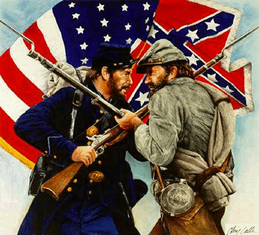
Essential Questions:
- What were the Union and Confederate strategies for victory? What were the relative advantages/disadvantages of the North and the South?
- How did the Civil War affect civilians (non-soldiers)?
- What were the major turning points of the war, and why were they turning points?
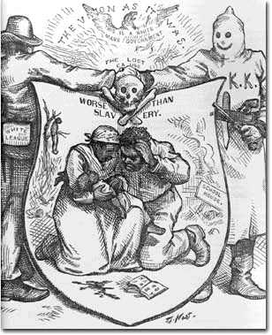
- How did the Civil War end? What were its effects of the Civil War?
- What were the different “phases” of Reconstruction and why did the shifts occur?
- Identify the central policies of Reconstruction. How did they affect post-Civil War society and economy?
- To what extent was Reconstruction a success or failure?
ID Terms:
Read each assignment carefully & A) record 2-3 main ideas for the section and B) identify the ID terms below in your own words. These will serve as excellent study tools when it comes test/quiz time. For each ID term, make sure you are able to A) define/describe (who/what/when/where) and B) explain why it is historically significant.
Reading/Topic | Syll # | Date Due | ID Terms
Chapter 11 Section 1: Resources, Strategies, and Early Battles (p.358-366) + Ess.Q. #1 | 1 |  | General Robert E. Lee  Anacdonda Plan  Minie ball (in the box)  Border states | General Stonewall Jackson  General Ulysses S. Grant  General George McClellan  Ironclads
Chapter 11 Section 3: Life During the War (p. 373-379)+ Ess Q. 2 | 2 |  | Income tax  Gov’t bonds  Homestead Act  Conscription/Draft riots | Copperheads  Suspension of habeas corpus  Life of a Civil War soldier
Chapter 11 Section 4: (p. 380-389) + Ess Q. 3 | 3 |  | Siege of Vicksburg  Battle of Gettysburg | Total war  Sherman’s March to the Sea
Chapter 11 Section 5: The War’s End (p. 388-395) + Ess Q ##4 | 4 |  | 13th Amendment  Appomattox | John Wilkes Booth  Reasons why North won
Chapter 12 Section 1: Rival Plans for Reconstruction (p. 402-409) + Ess Q. 5 | 5 |  | Lincoln’s 10% plan  Radical Republicans  Wade-Davis Bill  Freedman’s Bureau | Andrew Johnson: views, trial  Black codes  Military Reconstruction Act  13th, 14th, 15th Amendments
Chapter 12 Section 2: Reconstruction in the South (p.410-418)) | 6 |  | Scalawags  Carpetbaggers  Integration/segregation | Sharecropping  Tenant farming  Ku Klux Klan & KKK acts
Chapter 16 Section 1: Segregation and Social Tensions + Ess. Q 6 | 7 |  | Jim Crow laws  Poll tax  Literacy tests | Grandfather clauses  Booker T. Washington  W.E.B. Du Bois

