11 APUSH D Block
Mr. Bedar

Unit Guide: Exploration & Colonial America

(or, things you should know based on the summer reading; Brinkley Ch. 1-3)

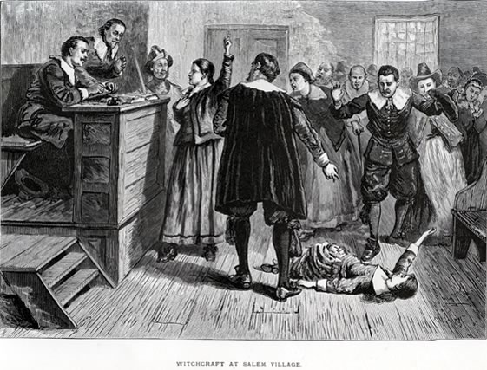 | 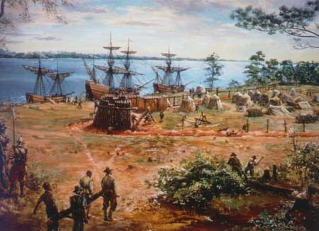

Essential Questions:
- How did the first interactions between Europeans and native peoples transform both groups?
- What motivated Europeans to explore and settle the North American colonies?
- How similar/different were the British colonies from each other?
- To what extent did an “American” culture develop in the colonies?

Study Questions
- How did different North American environments affect the political/social/economic development of Native American tribes?
- How did Native American tribes interact with one another, both positively and negatively?
- What is the Columbian Exchange and how did it affect both the “Old World” and the “New World”?
- How and why did different European patterns of colonization emerge in the Americas?
- How did European colonization lead to contact and conflict amongst the different European and native groups living in the Americas?
- How did increasing political, economic and cultural exchanges impact the colonial societies in North America and create an “Atlantic World”?
- How did Protestantism and British culture influence the development of the colonies?
- How did cultural interactions among American Indians, Africans and Europeans change each group?
- Why did the institutions of slavery and indentured servitude become important parts of life in the colonies?
- How were the thirteen colonies socially, politically and economically similar to and different from to each other?

