The Imperial Inquirer

With the war against Spain now over, we can now accurately determine if the actions of the US government were necessary. These actions were obviously determined after days of deliberation. Numerous actions by the Spanish Government left the US with the realization that physical conflict was the only option. We ourselves are a nation that came into legitimacy by fighting back against an oppressive ruler. The same goes for the Cuban people. They were merely attempting to fight for the natural rights that all human beings should possess: life, liberty, and pursuit of happiness. As a nation who once fought for similar goals, we had a duty to aid the Cuban people in their quest for freedom. In fact, during our fight for liberty, our founding fathers reached out to countries such as France for help and support. It was our time to play the supporting role. We had to become Cuba’s France.
It was not just the oppression of rights that made fighting inevitable; it was also the heinous actions of Spanish generals, such as General Valeriano Weyler. This man decided that the best strategy for fighting back against the rebels was extermination. Weyler’s reconcentration policy called for the separation of rebels from civilians. Civilians were placed in camps near military headquarters and treated inhumanely. Hundred of thousands of innocent people were killed. At this point, it would have been immoral not to intervene. As human beings, we could not let this massacre continue.
The final straw was the destruction of the USS Maine. The Spanish killed both Americans and Cubans without any repercussions. They showed no regard for human life. Spain left us no other option. We had to intervene for the sake of humanity. Now, with the threat eliminated, the US government can aid the Cuban people in establishing the democracy their country so desperately needed.
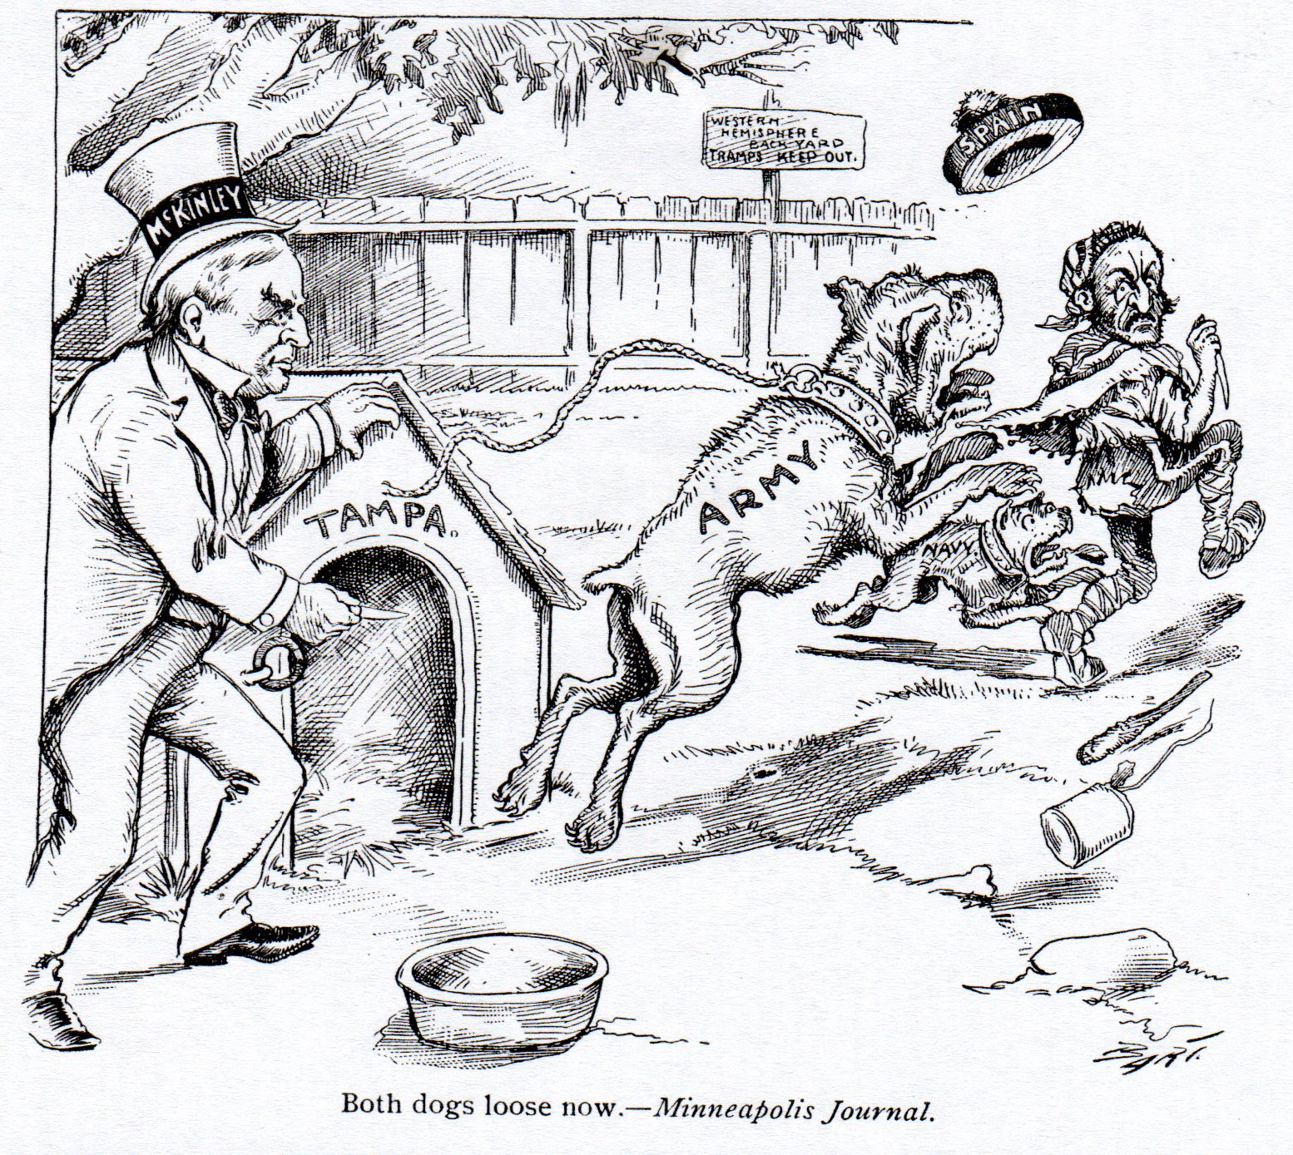

Up to this point, we in the United States have not concerned ourselves with the prospect of imperialism; rather, we have focused our energies mainly on ourselves, particularly from an economic standpoint. As European countries have expanded their economies into places like Africa and Asia, we have been left far behind. While our economy is quite powerful, European countries that have established vast empires could soon threaten its dominance. This would threaten the health and efficiency of our economy, and shows why we, too, must expand our territory as well. One of the best places to do this is Cuba, the island nation just 90 miles from our border, rich in economic opportunity and welcoming to our influence. The people of Cuba have been fighting their mother country, Spain, for well over a decade now, just as we fought against Great Britain in our revolution, and are begging for help from our military and economy. They already have the tools to start contributing to our economy immediately: a lucrative export in sugar cane, factories, mills, and a supportive population. Not only is it morally right to help them, but also the economic benefits could put us in a position of unparalleled dominance in the global system.

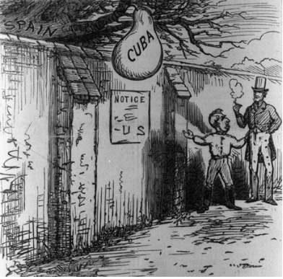

Letter to the Editor
It astounds me that you, the American people, can be so blind to your own history. After all, it was just a little over a hundred years ago when you revolted against the British Empire and established a sovereign nation--and justifiably so. A tyrannical king and a tyrannical parliament were forcing your hand and being unreasonably harsh, so you responded just as any freedom-loving people would. Yet now the United States wishes to enforce its will upon Cuba, an independent nation. So let me ask the American people: how is this illegal act of imperialism any different than British occupation of the Thirteen Colonies? You wanted your independence then, and we want ours now. Don’t get me wrong, we appreciate the United States’ help in the effort against Spain and we mutually agree that European presence in this hemisphere benefits no one. But now it is time for us to forge our own path, our own destiny; we did not battle the Spanish to merely become subjects of another powerful country. And if you have a shred of honor, you will allow us to maintain total independence.
Furthermore, I would argue that occupying Cuba would be no easy task, even for a country like the United States. The Americans believe that they will have easier access to our supply of natural resources if they directly intervene in Cuba. However, this will not be the case, for we will be compelled to resist if you forcibly take control of our land and we will stop at nothing to make matters as difficult as possible for America. If, on the other hand, the United States detaches herself from Cuban affairs, we will gladly engage in trade with her. The choice is clear: nullify the Platt Amendment and create a lasting alliance in this hemisphere, or occupy Cuba and face rebellion after rebellion until you are driven from our land.
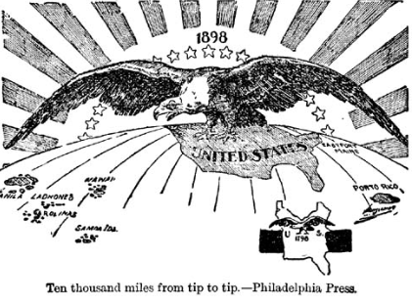

A Letter to McKinley
To my fellow compatriot President McKinley,

You must resist the urge to take control of Cuba. While it may be tempting to take advantage of a ripe, new country, so close to American soil, it violates the very principles that we hold up this great country of ours. We have intervened in Cuba, and have done our best to rid our hemisphere of the taint of European interference. However, now is the time to step back from Cuba, not to put our foot on their necks. This Platt Amendment is a flagrant violation of their rights, and will put our nation on a course of conquest for which the American people have no desire. You cannot sit idle while your stronger-willed friends force their way into the Cuban constitution, and you must resist the temptation to join them. While you may wish to be forever remembered as the president who began the American conquest of their hemisphere, this crown of imperialism will weigh heavily upon your brow. You will live to regret violating a country’s most sacred of rights: to govern and control itself. Allow the Cubans to help themselves, as we once did. The Cuban people demand that you relinquish the power that you have over them, and the American people demand that you tend to them as you do to the Cubans. An alliance with the Cubans could be prosperous for all, should you allow it to prosper. Do not allow the dream of an imperial crown to impede your vision; no amount of success can justify desecrating Cuba with this Amendment, and no bounty of colonies can make up for the systematic destruction of American ideals that you lead. Think hard about the consequences of intervention in Cuba, and then perish the thought thereafter.

