9th Grade World History

Mr. Bedar

Study Guide: The Byzantines Early Middle Ages

Essential Questions:  - What factors contributed to the fall of Rome?  - To what extent was the Byzantine Empire a continuation of the Roman Empire? To what extent did it differ?  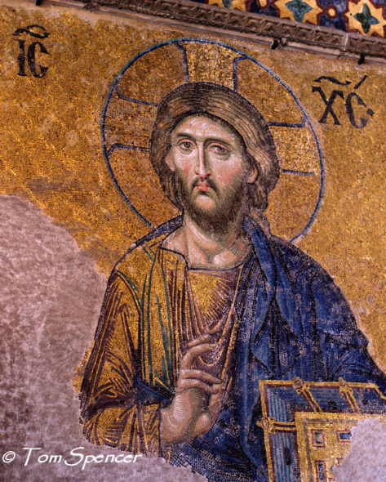  - What is the legacy of the Byzantine Empire? Consider our categories (PECS)  - How did new invasions affect Europe after the fall of Rome?  - What led to the rise of Feudalism and Manorialism in the Middle Ages? How did these systems function (politically, socially and economically)?  - What was the role of the Church in Western Europe during the Early Middle Ages?  - In what sense did “civilization” decline in the absence of Rome? To what extent were these really the “Dark Ages”? | 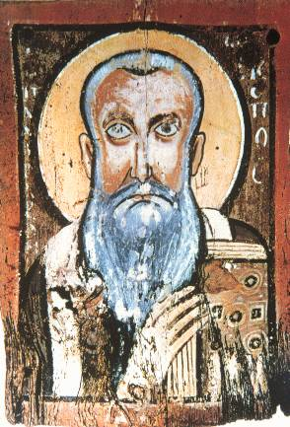
TERMS:
Eastern Roman Empire  Constantinople  Justinian  Theodora  Nika Revolt  “Greek fire” | Hagia Sophia  Clergy  patriarchs  Eastern Orthodox Church  Ottoman Empire | Interdict  Excommunication  Homage/Investiture  “Trial by Ordeal”  “Dark Ages”  Seven Sacraments  Seven Deadly Sins
Sagas  Longships  Leif Eriksson  Viking Advancements  Manor system/Manorialism  Serfs/free peasants  Castles  Fief | Magyars  Muslims  Lord  Knight  Oath of fealty  Manorial  Vassal  Feudalism/feudal system | St. Augustine of Hippo, “City of God”  Benedictine Rule  Pope Gregory the Great  Christendom Monasticism/monks/nuns

PLACES:
Mediterranean Sea, Red Sea, Black Sea, Aegean Sea, Rome, Constantinople, Jerusalem, Gaul, Egypt, Spain, Nile River, Tigris River, Euphrates River, Eastern Roman Empire, Western Roman Empire
- Using a different colored pencil/marker, trace and shade the area of the Byzantine Empire around 565 AD (peak of the empire)
- Using a different colored pencil/marker, trace and shade the area of the Western Roman Empire that was created when Diocletian split the empire.
- Using a different colored pencil/marker, trace and shade the area of the Eastern Roman Empire that was created when Diocletian split the empire
(there will be overlapping of colors)
- Use a BROWN colored pencil to shade in any remaining land, and a BLUE colored pencil to trace the rivers, and color all the water!

