11 U.S. History F Block
Mr. Bedar

Unit Study Guide: The Gilded Age

Essential Questions:
- How did the U.S. economy transform in this period?
- Were the industrial giants of the Gilded Age “Captains of Industry” or “Robber Barons”?
- How did labor unions form and what were their goals? How effective were they?
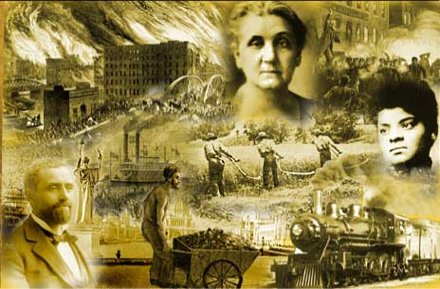
- How did immigration and urbanization shape US society in the late 19th century?

ID Terms:
Syll. # | Reading/Topic | Date Due | ID Terms
1 | Chapter 13 Section 2: The Rise of Big Business (p. 443-449) + ess Q #1 |  | Corporation  Monopoly  Cartel  John D. Rockefeller  Horizontal integration  Andrew Carnegie | Trust  Vertical integration  “robber barons”  Social Darwinism  Sherman Antitrust Act
2 | Chapter 13 Section 3: Organized Labor (p. 450-457) + Ess Q #3 |  | Sweatshops  Company towns  “wage slavery”  Collective bargaining  Socialism  Knights of Labor | AFL, Samuel Gompers  Haymarket Riots  Homestead Strike
3 | Chapter 14 Section 1: The New Immigrants (p 462-471) |  | “New” immigrants  Push vs. pull factors  Ellis & Angel Islands  Assimilation | Americanization  “Melting pot”  nativism  Chinese Exclusion Act
4 | Chapter 14 Section 2: Cities Expand and Change + Ess Q #4 |  | Urbanization  Skyscrapers  Mass transit | Tenements  Problems of cities
Other terms to know (from notes and class discussion) |  |  | Reasons for wealth & poverty  Horatio Alger stories  “American Dream”  Laissez-faire  Social Darwinism  Capital & Capitalism  Sole Proprietorship | Corporation (LLC)  Ida Tarbell  Rebates, drawbacks  Melting pot, salad bowl, ethnic stew  The New Colossus  Jacob Riis: How the Other Half Lives

