11 U.S. History D Block
Mr. Bedar

Unit Guide: The Gilded Age

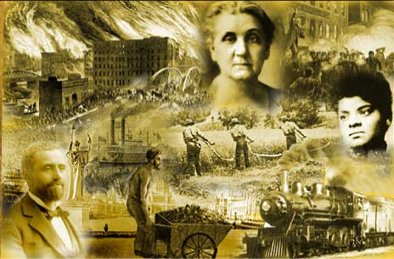
Essential Questions:
- How did the U.S. economy change in the late 19th century?
- How did US society change in the late 19th century?
- How did US politics change in the late 19th century?

Study Questions
- How did the philosophy of 19th century liberalism (laissez-faire and social Darwinism) contribute to the rise of “Big Business”?
- What is a corporation and how did it change the American economy?
- How did the railroads change the American economy? How did they impact the West?
- To what extent did the federal government regulate the economic and social changes that took place during this era?
- Were men like Carnegie, Rockefeller, and Vanderbilt “Captains of Industry,” or “Robber Barons”?
- Explain the formation and goals of labor unions during the Gilded Age. How effective were labor unions during this time?
- How did immigration (and nativism) impact American society?
- What contributed to urbanization and what problems resulted?
- To what extent does the “myth of the West” match its reality?
10.Why did the political parties fail to confront the major social and economic issues of the late nineteenth century?
- In what ways does the time period after the Civil War in the United States deserve the title “The Gilded Age”?

