10 Modern World History (H) E Block

Mr. Bedar

Unit Syllabus: The Industrial Revolution
Essential Questions:
- What factors are necessary for an area to undergo industrialization? Why did the IR begin in Great Britain?
- What are the major changes in how work was done during the IR?
- Describe how society changed as a result of the IR (+/-) effects
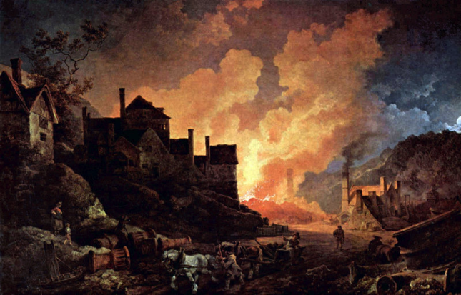
- What were the various legislative and ideological responses to the problems of the IR? (laws, development of econ. theories)

Reading and Homework Assignments:
Reading each section carefully and complete the corresponding HW assignment

Reading | Date Due | ID Terms
Ch. 19 Sec. 1: The Industrial Revolution (p. 581-585) Part I |  | Factors of industrialization  Capital  Entrepreneurs  Cottage industry | Steam Engine  Puddling  Railroads
Ch. 19 Sec. 1: The Industrial Revolution (p. 585-588) Part II |  | Steamboats  Irish potato famine  Industrial capitalism  Industrial middle class (“New Bourgeoisie”) | Industrial working class  Factory acts  Socialism  “utopian socialists”  Robert Owen
Ch. 20 Sec. 1: The Growth of Industrial Prosperity (p.615-620 ) |  | Second Industrial Revolution  Edison, Bell, Marconi  Model T  Internal combustion engine  Marx & Engels | Bourgeoisie  Proletariat  Dictatorship  German SPD  Revisionists  Trade unions
Ch. 20 Sec. 2: The Emergence of Mass Society (p.621-628) |  | Urbanization  Mass society  “white collar workers”  Victorian society | feminism  universal education  leisure

