COINTELPRO: White Hate Groups:
A Legitimate Attempt to Take the Violence Out of “Hate”

Sonya Jampel
3.28.14
AP American History
D Block
Bedar
Junior Thesis
During the Counterintelligence (COINTELPRO) operations completed by the Federal Bureau of Investigation from 1956 to 1971, 98% of information illegally gathered was on leftist or civil rights groups with radical ideas differing greatly from those of J. Edgar Hoover, director of the Federal Bureau of Investigation (FBI). Only 2% of the information collected pertained to white hate groups like the Ku Klux Klan (KKK) with ideals similar to Hoover’s. Why did COINTELPRO target mostly radical groups but also the Klan and other white hate groups? Was the attack on Klan just a token attempt? COINTELPRO: White Hate Groups was not a token endeavor by John Edgar Hoover but instead a legitimate attempt to take the violence out of the Ku Klux Klan. Hoover created COINTELPRO: White Hate Groups, which used various methods such as sending postcards and targeting KKK leaders, to ensure that his Anti-Civil Rights Movement was not undermined by the fringe, violent KKK.
Starting in the mid-1950s, the Civil Rights Movement began in hopes of gaining equal rights for African Americans under the guidance of Martin Luther King Jr. King organized the nonviolent boycotts of segregated buses to force civil rights reform, gave his famous “I Have a Dream Speech,” wrote “A Letter from Birmingham Jail” to instruct the community about nonviolent civil disobedience, and headed the March on Washington for Jobs and Freedom to protest for equality. The Black Panthers lead by Huey P. Newton and Bobby Seale took a violent approach to the Civil Rights Movement using “any means necessary” to fight for their rights. Other groups such as the Student Nonviolent Coordinating Committee (SNCC) organized sit-ins at segregated restaurants, and the Freedom Riders attempted to desegregate bus terminals with their insistence on riding segregated buses. Through hard work, revolutionary ideas, and legislation such as the Civil Rights Act of 1964 and the Voting Rights Act of 1965, African Americans came closer to achieving racial equality in the United States during the Civil Rights Movement.
However, not all Americans living at the time supported the idea of racial equality. Reflecting the racist beliefs of some Americans at the time, J. Edgar Hoover, director of the FBI from 1924-1972, imposed his views on the FBI, used it as tool to achieve his own personal ends, and undermined the Constitution. Born in 1895 in Seward Square, DC, Hoover lived in an all-white neighborhood where Jim Crow Laws governed the racial scene beginning in 1900. Hoover voiced racially charged comments with his belief that “mixed education” could lead to horrific “racial marriages.” He began to force his hope for a homogenous, white America on the FBI; in the 1960s, when the American Civil Liberties Union investigated hiring practices, Hoover shuffled around the eight black workers out of 4,000 in the Justice Department to give the appearance of a diverse staff. Sensing racism in his employment choices, President Robert Kennedy, in 1962, wasn’t pleased and requested Hoover to diversify his staff. Hoover responded, “That’s not going to happen as long as I’m Director of the Bureau” demonstrating his control over the FBI. Former agent Wesley Swearingen commented on Hoover’s leading of COINTELPRO: “COINTELPRO was not the creation of an autonomous bureaucracy run amok but the calculated extension of what many racist agents considered a Hoover-authorized personal vendetta” and compared it to a “Gestapo skin head racist.” Senator Joseph R. McCarthy stated, “The Federal Bureau of Intelligence is J. Edgar Hoover.” The name was synonymous with the agency, demonstrating his complete control and ability to institutionalize racism by imposing his own beliefs on the FBI.
Although the FBI originated in 1908 to help regulate interstate commerce and antitrust cases, by the 1960s it had ballooned into a larger agency above the control of the executive government with the onset of the Cold War and public hysteria. In 1956, the FBI, under the unmonitored, authoritarian reign of Hoover, switched to counterintelligence undermining the Constitution and stopping “subversive” groups from disrupting the order of society. Hoover created a program called COINTELPRO (COunter INTELligence PROgram) to act against dissidents and subversive groups in his own country. The first COINTELPRO movements were against the Communist Party in 1956 and the Socialist Workers Party in 1961. Originally, the FBI gathered intelligence by completing detective work to obtain as much information as possible. However, with the onset of counterintelligence, the FBI began to act on the intelligence gathered to prevent unwanted actions of groups by planting evidence, sending postcards, placing informants, opening others’ mail, and wiretapping.
Before any formal action against the Civil Rights Movement, Hoover created COINTELPRO: White Hate Groups on July 30th, 1964. It began on a smaller scale with only fourteen offices in the south, along with New York, Baltimore, and Chicago but eventually blossomed into a total of twenty-six field offices. COINTELPRO: White Hate Groups aimed to halt the violent actions of the KKK and other white hate groups which were discrediting the good name of white America and his Anti-Civil Rights Movement, a calculated attack on the Civil Rights Movement using his power as the leader of the FBI.
To continue to address his growing concerns with the rising Civil Rights Movement and those with radical ideas, Hoover developed COINTELPRO: Black Hate Groups in 1967 and then created COINTELPRO: New Left in 1968 to target left wing, anti-war activists, “to expose, disrupt, misdirect, discredit or otherwise neutralize the activities” of these groups. Hoover, nervous about the perceived threats disrupting the status quo, turned to systematic counterintelligence. Historian Tim Weiner, author of Enemies: A History of the FBI, described in an interview on National Public Radio (NPR) the decision to pursue counterintelligence:
Hoover saw the Civil Rights Movement from the 1950s onward and the Anti-War Movement from the 1960s onward, as presenting the greatest threats to the stability of the American government since the Civil War. These people were enemies of the state, and in particular Martin Luther King [Jr.] was an enemy of the state. And Hoover aimed to watch over them. If they twitched in the wrong direction, the hammer would come down.

Believing that communists had infiltrated the Civil Rights Movement, Hoover created his own Anti-Civil Rights Movement attempting to stop the radical change in that would occur if African Americans acquired equal rights. With the accusation of equal rights, blacks could gain power in government and in society, completely challenging Hoover’s conceived racist concepts of social hierarchy. Recognizing no boundaries, Hoover bugged King’s private room, sent him an audio copy of King having sex with a woman that was not his wife, and gave him an anonymous letter which read, “King, look into your heart. The American people would know you for what you are — an evil, abnormal beast. There is only one way out for you. You better take it before your filthy, abnormal fraudulent self is bared to the nation.” The FBI suggested that King commit suicide to do himself and the nation a favor. Hoover attacked real and imagined enemies creating an Anti-Civil Rights Movement in attempt to maintain the status quo.
COINTELPRO: White Hate Groups was a key part of Hoover’s larger goal of stopping violent and disruptive actions. The majority of COINTELPRO: White Hate Groups targeted the Ku Klux Klan, however the program also investigated other groups such as the American Nazi Party, the Council for Statehood, the Viking Youth of America, the United Freemen, the White Youth Corps, the Alabama States Rights Party and others. The United Klans of America claimed to “stand for everything that is America…We’re not anti-anything. We’re simply pro-American” and cited George Washington, Abraham Lincoln, and Daniel Webster as role models. The Klan continued to claim in 1961 that its purpose was “to teach patriotism, to support the Constitution and Law of the United States, to maintain the liberty bequeathed to us by our forefathers, and the preserve the American way of life.” However instead of pursuing these goals that all Americans hope to live by through peaceful measures, the Klan followed these aims violently to ensure a homogenous, white community. Historian Kenneth O'Reilly describes Hoover’s position towards the KKK: “The director may have ordered his agents to spy on the frightened people along with the frightening Klan, but he was on their side. He waged war on the Klan because the Klan had discredited the good name of white America” Hoover had similar hopes for the country as the KKK but wanted them enforced by different, less violent means, and therefore he viewed the KKK as detrimental to his Anti-Civil Rights plan.
The hands off approach to the Citizens’ Council demonstrates COINTELPRO: White Hate Groups’ focus on preventing belligerent actions of the KKK rather than changing the underlying ideals. Another white supremacist group, Citizens’ Council shared the same dream of homogenous America with Hoover and the Klan, however followed peaceful means such as rallies and economic reprisals as opposed to burnings and killings. Citizens’ Council generally contained leading members of the business community, lawyers, and local police whereas the Klan usually contained poor, rural, and uneducated men. Hoover sided with Citizens’ Council and decided to let them be due to its respectable demographics and nonviolent approach. He still left open the option for the peaceful manifestation of his ideals through Citizens’ Council. In contrast with his attitude towards the Citizens’ Council, Hoover strongly believed the Klan’s “subversive” actions must stop. Historian Kenneth O’Reilly describes Hoover’s philosophy towards the Ku Klux Klan:
Hoover saw the Ku Klux Klan as another subversive threat to the peace and stability of middle America, but he also saw the Klan as a threat to the good name of the anti-civil rights movement. Klansmen were discrediting all types of resistance, including the FBI’s preferred forms, and for that, the director decided, they had to be stopped.

Martin Luther King and black rights activists viewed the KKK and the Citizen’s Council as, “a two-headed monster of reactionary opposition” for their similar beliefs. However, Hoover viewed them differently with only the KKK, with its violent actions, posing a threat to the Anti-Civil Rights movement.
From the creation of COINTELPRO: White Hate Groups, the main goal was regulation and control of the violent actions. William Sullivan, the leader of this program appointed by Hoover, recalled his conversation with Roy Wall, special agent in charge of the Philadelphia, Mississippi office, “I asked Roy, ‘If we merge them [the KKK tribes] into one, can you control it and if necessary destroy it?’ Roy said, ‘Yes we can do that’ I told him to go ahead.” From the beginning for the program, the directors were concerned with the KKK ruining the good name of the Anti-Civil Rights Movement. The Bureau expressed its goal as: “to expose, disrupt, and otherwise neutralize the activities of the various Klan and hate organizations… [and continue] the policy of aggressively seeking out persons addicted to violence even though they have not violated a federal law as of yet.” From the onset, the focus was on the violence of the Klan and not the ingrained beliefs. Historian David Cunningham argues there are two ways to protest the status quo. The first method is to suggest a new set of ideals, and the second method is to create disturbance through disruptive actions. The difference between the COINTELPRO targets is drawn here. While the New Left and the Black Rights Movement employed both methods of being a threat to the government, the KKK utilized only the second method. Therefore, the program’s goal was altogether different from the onset.
On September 2nd 1964, Hoover sent a letter to the special agents reiterating the goal of exposing, “the devious maneuvers and duplicity of these groups…to public scrutiny through the cooperation of reliable news media sources and consideration should be given to disrupting the organized activity.” Focusing on the “devious maneuvers,” Hoover referred to the potentially violent actions that could ruin the name of the movement. He hoped to recruit the newspapers to help him in his mission. Hoover told Martin Luther King Jr. his goal was to intimidate and to put “the fear of God” in the Klan. Describing his success in controlling the violence of the Klans in Mississippi, Hoover wrote to Marvin Watson, special assistant to the President, on September 2nd 1965 of his achievement: “We have been successful to date in holding the Klan violence in the entire state to an absolute minimum.” Hoover attempted to combat the militant actions of the KKK and reported success in doing so.
Demonstrating the program’s aims in 1968, G. C. Moore, an FBI agent, wrote a treatise to be disseminated to the press. He explained, “America doesn’t need extremism in any shape or form…Our country will not be run by white or black extremists in the foreseeable future.” Moore compared the Klan to the Black Panthers. He forcibly criticized the militant actions of both groups, focusing on maintaining the status quo, believing that neither black nor white violence should be tolerated. He preached that it is the government’s job to end militant actions threatening to wreck the finely balanced system of power. With the creation of COINTELPRO: White Hate Groups, the FBI hoped to control the violent actions of the KKK and other white supremacist groups to maintain the legitimacy of the Anti-Civil Rights attack.
An authentic attempt to destroy the violent activities of the Klan, COINTELPRO: White Hate Groups suppressed the Klan by sending postcards, posting bulletins, delivering packages, and specifically targeting its leaders. Throughout the mission against the KKK, 477 actions occurred compared to the 485 actions in COINTELPRO: New Left; the similar amount of actions in the two COINTELPRO missions demonstrates the legitimacy of the mission against the KKK. One of the major actions involved mailing postcards to the Klansmen's houses in order to unveil the secrecy of the membership and to expose the immoral spending of membership dues. In a memo to Sullivan, F. B. Baumgardner, Internal Security Section Chief, described how the postcards would remove, “one of the Klan’s most potent weapons-its veil of secrecy” and that “the purpose of these cards is to cause the public identification of Klan members and spread dissent.” When the postman delivered the postcard to the house or the office, the Klansman lost respect, causing disruption in the family or loss of job. Baumgardner planned to send 6,000 postcards in total to 21 field offices.
For example, the second of two postcards in Image 1 depicts a Klansman sitting in a chair with his mask partly pulled off by another Klansman behind him. The postcard reads, ‘INVISIBLE GOV’T Someone is Peeking Under Your Sheet.” Neither face can be seen suggesting that anyone could have been revealed. Also, even a fellow Klansman could have revealed the membership of another, a legitimate fear. Sometimes, the FBI bribed poorer Klansmen to expose fellow Klansman. A person peers under the mask, coming from behind, suggesting that a Klansman could have been revealed when he was not expecting it. The word “INVISIBLE” emphasizes the lack of secrecy of the Klan and the all-controlling government. On the postcard, the present progressive tense of “is peeking” indicates that the unveiling could have happened at any time. The postcard inspired fear and encourages the Klansmen to quit. The third postcard (bottom Image 1) shows a Klan leader and his wife lavishly indulging in drinks. Not only did the postcard reveal the membership of the recipient, but also might caused him to suspect the leadership. The recipient questioned if his membership dues were solely spent for the leaders’ personal enjoyment. Instilled fear and skepticism, the postcards urged members to quit the Klan.
Commenting on the effectiveness of the postcards, the Cincinnati Enquirer described the reaction of one unidentified Klansman in an article titled, “‘You Are Known Member of the Klan,’ Ohio Card Says.” The paper reports the citizens’ reaction: “Since it is a postcard, the Klan leader said, ‘Some of the postal employees and neighbors of the people are getting some juicy gossip.’” Another method employed to reveal the identity of Klansmen was placing bumper stickers on their cars. Inspiring members to quit the Klan, the counterintelligence action demonstrates the legitimacy of the FBI’s attempt to stop the violent actions of the Klan by any means necessary. The FBI forced the townspeople to question the motives and to discredit the name of the KKK.
To attempt to end the violent actions of the Klan, the FBI invented, in 1966, the National Committee for Domestic Tranquility (NCDT), said to be directed by an obscure, dead politician named Harmon Blennerhassett, who once gave financial support to Aaron Burr. Even the name of the Committee, containing the words “Domestic Tranquility” directly from the Constitution, suggests the FBI’s purpose to attack the non-tranquil or violent actions of the Klan. In a memorandum from Baumgardner to Sullivan, Baumgardner describes the NDCT as a “vehicle for attacking Klan policies and disputes from a low key, common sense, and patriotic position” and paints the Klan as a “lunatic fringe” group (see Image 2). The FBI decided to make the Committee, in order to ensure secrecy of the origin, based out of Dayton because there are 19 Daytons in the United States. Baumgardner attached to the memorandum a NCDT “bulletin” to be disseminated to 21 offices with 25 copies each in 11 states. In the bulletin, the NCDT urged the Klansmen to “Quit the Klan, and Back Our Boys in Vietnam” by suggesting that, “these irresponsible Klan leaders [are] joining hands with the communists” by feeding the scare of communism and by giving the impression that the United States was lawless . Under the name of the NCDT, Baumgardner appealed to patriotic nature of Klansmen in attempt to convince them to quit the group.
Attempting to persuade members of the Klan to quit as well, the FBI delivered packages to meetings. On June 15th 1966, six members of the Coon Hunter’s Club, also known as the “Harris County Klavern” participated in a “cross burning incident” in Cleveland, Texas. The FBI responded by transporting a package with remains of the cross to the meeting on Tuesday night at 9pm. They hoped to “unnerve some of the weaker-hearted members and perhaps convince other members that such activities could not be engaged in without their being identified and possibly persecuted in the future.” The public did not know the locations and the times of the meetings and the delivery challenged this important secrecy. The action attempted to scare the members of the Klan into not engaging in those militant actions again.
Through informants and targeting Klan leaders, the FBI tried to disrupt the Klan’s ability to operate. The FBI ruined the name of the leader of Alabama’s United Klans of America, Robert Shelton, by publicizing his strange eating habits, his unusual relationship with his wife, and even the evidence of possible black ancestry. The information about Shelton could be false as long as it was believable enough to demolish his reputation. The FBI even disseminated a joke book entitled United Klowns of America, Inc., KKKK for the purpose of defaming Imperial Wizard Shelton. Anonymously mailed to other Klan members, the book caused members “to view the leader and organization from a different vantage point” and was a “serious effort at counterintelligence.”Along with targeting the Klan leaders, the FBI had about 2,000 informants at its height in 1964 or about 20% of Klan members. The informants provided information about the next location of violent actions. By using informants, attacking leaders, sending postcards, delivering packages, and posting bulletins, the FBI attacked the KKK and attempted to disarm its violent tendencies.
Although some historians suggests that COINTELPRO: White Hate Groups was just a token attempt, sideshow, or outright disregard an analysis of it, the initiative was indeed a legitimate endeavor to control the Ku Klux Klan. However, the goal was slightly different than other COINTELPRO missions. Historian Kenneth O’Reilly views COINTELPRO: White Hate Groups as, “a sideshow to the real war” with the ‘real war’ as that specifically against the Civil Rights Movement and the New Left. Instead, the mission against the KKK was an essential part of the Anti-Civil Rights Movement, trying to clean the name of white America.
Historians Ward Churchill and Jim Vander Wall fail to include an analysis of COINTELPRO: White Hate Groups in their book, The COINTELPRO Papers: Documents from the FBI’s Secret Wars Against Dissent in the United States which includes documents and commentary on several of the FBI’s counterintelligence programs against the New Left, the Communist Party, the Puerto Rican Independence Movement, the Black Liberation Movement, the Socialist Workers Party, and the American Indian Movement. They omit an analysis on the counterintelligence program against the KKK “because it seems to have been altogether different in intent…its purpose seems all along to have been not so much as destroy the Klan and related groups as to gain control of them in order to use as surrogate forces against the left.” Although the goal seems to differ from other counterintelligence goals, the mission had a long lasting effect on the KKK leading to its decline and deserves analysis.
Historian Brian Glick explains the token attempt of COINTELPRO: White Hate Groups:
These groups received substantial funds, information, and protection-and suffered only token FBI harassment--so long as they directed their violence against COINTELPRO targets. They were not subject to serious disruptions unless they breached this tacit understanding and attacked established business and political leaders...in the guise of using COINTELPRO against ‘white hate groups’ the FBI actually subsidized, armed, directed, and protected a sordid array of racist right-wing thugs.

Glick incorrectly states that the KKK was “not subject to serious disruptions”; Hoover took numerous intricate actions against the Klan such as the postcard action and the NCDT. Also, the actions could not be called “token” due to their all expansive manner across many offices and states as well as efforts to completely disarm the Klan and force members to quit. If Hoover only wanted to protect himself and other “racist right-wing thugs,” he would not have made elaborate plans to send an army of agents across the country to wreck the name of the Klan. Glick may also provide a biased opinion due to his personal experiences with the counterintelligence program as a lawyer for the Students for a Democratic Society and the Anti-War Movement of the 1960s.
COINTELPRO: White Hate Groups should be viewed as a legitimate attack on the Klan, however the assassination of Viola Liuzzo, a white woman and Friend of SNCC, by Gary Thomas Rowe near Selma, Alabama questions its legitimacy for many historians. On March 25th 1965, Rowe, an FBI informant, murdered Liuzzo while driving past with a group of fellow Klansmen. The three other men each received ten years in prison while Rowe walked away under the “witness protection program,” possibly for his cooperation and stature in the FBI as an informant. Rowe also planned a bombing in Birmingham, Alabama which killed four black children.
Rowe appears to be the perfect example of the FBI supporting the KKK even in its violent endeavors; however, this is not the case. John Doar, Assistant Attorney General and head of the Justice Department’s Civil Rights Division, claimed, “You take informants as they come. You and I might have saved Ms. Liuzzo’s life, but you and I could never become FBI informants.” F. J. Baumgardner agreed, informants “did not have to be lily white....He [Gary Rowe] couldn’t be an angel and be a good informant” because the FBI wanted to know “where the action was.” For an informant to be effective, he had to be involved with the KKK and not have his fellow Klansmen question his loyalty. The FBI paid Rowe and other informants $400 a month in exchange for vital information for the Bureau to fuel the counterintelligence program.
The actions of COINTELPRO: White Hate Groups, along with the changing social trends of the era, eventually lead to the decline in popularity of the KKK. The Klan fell apart because of decreased political opportunities, reduced organization, and lack of mobilization possibly due to the counterintelligence actions of the FBI. A former agent of the FBI claimed that COINTELPRO “blew [the Klan] all to hell.” COINTELPRO actions helped to discredit Klan leaders, build distrust among the Klan, and convince members to quit. To exemplify the changing sentiment, in the late 1960s, billboards in small town South Carolina read “Stamp Out Boll Weevils, Tobacco Worms, and the Ku Klux Klan,” and the state of Alabama began to offer $20,000 for evidence of people responsible for racial violence. Klan membership dropped from a peak of 14,000 in 1964 to 4,300 in 1971. COINTELPRO was at least partially responsible for the eventual decline of the KKK because it created skepticism throughout and around the Klan.
Not a token effort, COINTELPRO: White Hate Groups run by J. Edgar Hoover was a sincere attempt to stop the violent actions of the Ku Klux Klan and other white supremacist groups through counterintelligence programs such as sending postcards, using informants, creating bulletins, and targeting leaders to better control the “lunatic fringe” group. Hoover aimed to prevent the KKK from ruining the name of the Anti Civil Rights Movement, and his actions hastened the decline of the KKK. By diminishing the delegitimizing influence of the Klan, COINTELPRO: White Hate Groups may even have permitted “the rise of a more sophisticated and perhaps more damaging racism as an intractable force in national politics.” Institutionalized racism lets the government decide who can succeed and who cannot. Also, each of the COINTELPRO initiatives, including White Hate Groups, exemplified how Hoover imposed his beliefs on the rest of the nation. Overextended, unchecked executive power, threatens to ruin the American dream of equal opportunity and freedom of speech. Change cannot happen if one person’s opinion can control the whole country.
Although COINTELPRO was ended by 1971, President Obama still grapples with the potential of an overreaching government and the NSA. In his speech on January 17th, 2013, the President spoke about his opinions and policy on the questionable actions of phone tapping and its intrusion into the lives of America’s citizens, and warned of too much government power: “And yet, in our rush to respond to a very real and novel set of threats, the risk of government overreach-the possibility that we lose some of our core liberties in pursuit of security-also has become more pronounced.” Like Hoover’s fear of internal dissidents, President Obama struggles with the external fear of terrorists and drawing the line between security and freedom. Word Count: 4,441

Appendix:
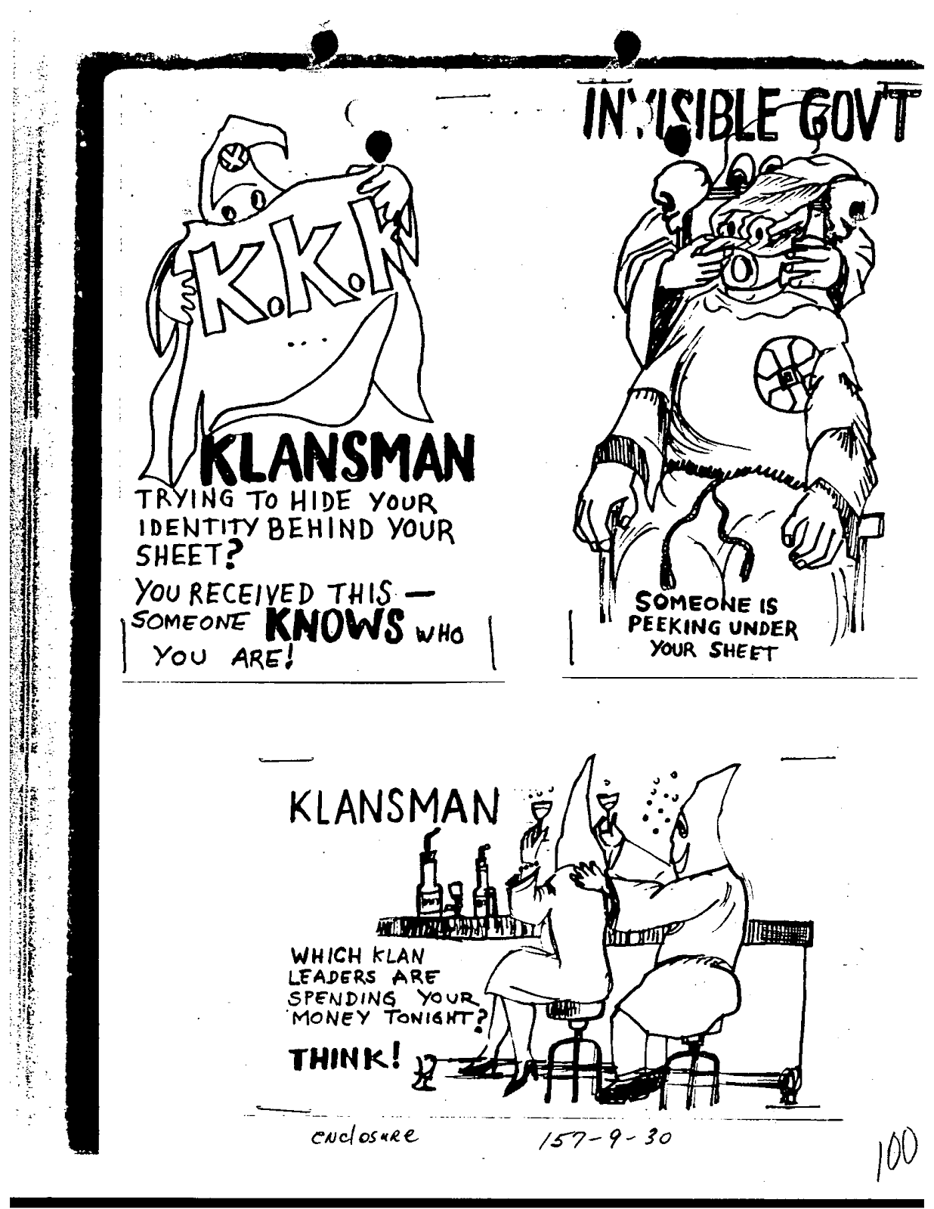

Image 1: F. J. Baumgardner sent these three postcards to William Sullivan to be disseminated to the field offices. The field offices mailed the postcards to members of the Ku Klux Klan in order to expose the secrecy of the membership or the immoral spending of the membership dues.
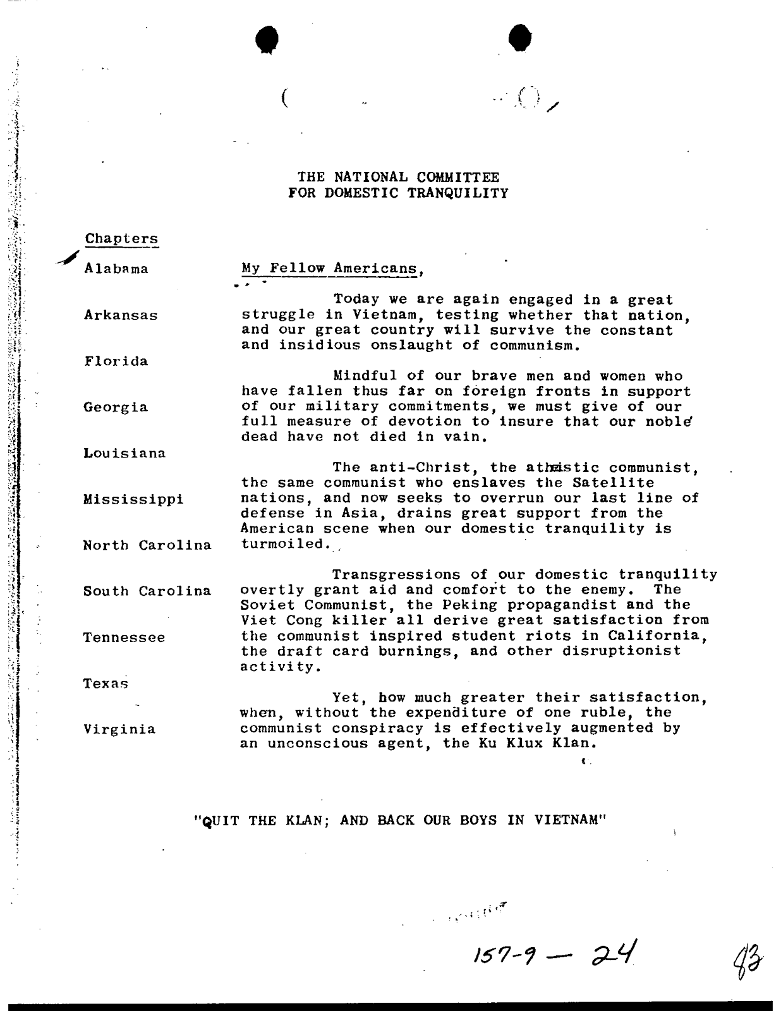
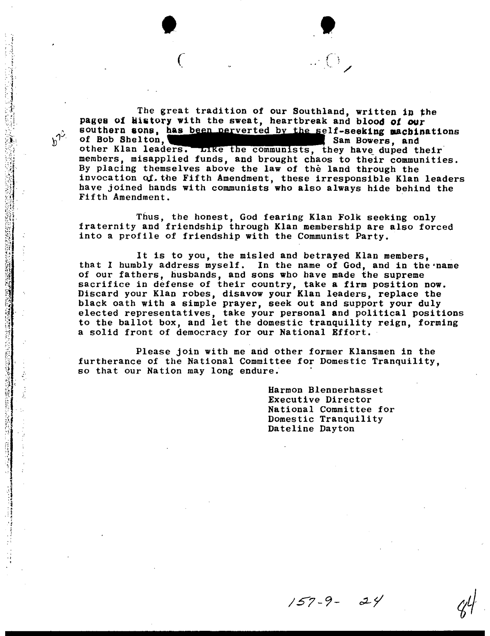

Image 2: This bulletin was attached to a Memorandum from F. J. Baumgardner to Sullivan to be disseminated to the field offices. One section is crossed out as to not ruin a possible Klansman’s reputation. Long deceased Harmon Blennerhassett, a politician who funded Aaron Burr, was the fictional character assigned to run the National Security of Domestic Tranquility which produced the bulletin.

Annotated Bibliography:

"American Civil Rights Movement". Encyclopedia Britannica. Encyclopedia Britannica Online.
Encyclopedia Britannica Inc., 2014. Web. 06 Feb. 2014.

After completing my rough draft, I realized that I needed more information on the Civil Rights Movement in general if I was going to argue that Hoover conducted an Anti Civil Rights Movement. I used this article from the Encyclopedia Britannica to find background on the movement and then use to introduce my paper. I already knew most of the background I found but found it helpful to double check my knowledge and read it all in one place.

Barnhill, John H., Robbie Lieberman, and Jay Larson. "J. Edgar Hoover: Did FBI Director J. Edgar Hoover Abuse the Power of his Office During the Red Scare to Promote his Personal and Political Agenda?" History in Dispute. Ed. Robbie Lieberman. Vol. 19: The Red Scare After 1945. Detroit: St. James Press, 2005. 173-179. Gale Virtual Reference Library. Web. 23 Nov. 2013.
This was one of the first sources I used but then decided to focus on a different time period mentioned in the article. However, it provided information on the illegal actions of Hoover, undermining the Constitution, to achieve his goals during the Red Scare. Similar tactics were used against the KKK and later COINTELPRO projects, which raised the same questions.

Black, Brady, Ed. "'You Are Known Member Of Klan,' Ohio Cards Say." Cincinnati Enquirer 24 May 1966. FBI Records: The Vault. Web. 18 Jan. 2014.

This newspaper article published in the Cincinnati Enquirer was attached to memo from the SAC to Hoover demonstrating the success of the postcard counterintelligence action. The article describes the reaction of a Klansman to the postcards sent out. I used this article to display the effectiveness of the action and the legitimate attempt of the FBI to disrupt the KKK.

Churchill, Ward, and Jim Wall. The COINTELPRO Papers: Documents From the FBI's Secret Wars Against Dissent in the United States. Cambridge, MA: South End Press, 1990. Print.
When I found this source, I thought it was going to be awesome and chock full of primary sources. However, Churchill and Wall mentioned in the footnotes of their book that they decided not to include information on the COINTELPRO-White Hate Groups and instead dismissed the project as a token attempt and altogether different in attempt. This decision to omit the whole COINTELPRO: White hate Groups program speaks for itself. It did referenced Spying on Americans: Political Surveillance From Hoover to the Huston Plan and Attack on Terror: the FBI Against the Ku Klux Klan in Mississippi for more information. It also provided instances of where the FBI supported the KKK instead of undermine it.
"Civil Liberties: Did Anticommunist Measures at the Onset of the Cold War Threaten Civil Liberties and Domestic Freedoms in the United States?" History in Dispute. Ed. Benjamin Frankel. Vol. 1: The Cold War: First Series. Detroit: St. James Press, 2000. 73-81. U.S. History in Context. Web. 13 Jan. 2014.
I used this source for background on the Cold War and the hysteria of the public at the time. After reading it, I could better place myself in the shoes of the government at the time to understand the creation of a seemingly overreaching counterintelligence program that violated the Constitution.
Cunningham, David. There's Something Happening Here the New Left, the Klan, and FBI Counterintelligence. Berkeley: University of California Press, 2004. Print.
This was my juiciest book. It directly addressed COINTELPRO-White Hate Groups and compared it to the campaign against the New Left. The thesis stated that it wasn’t a token attempt and that although the mission had a different goal of just suppressing the violent actions and not the ideals, the outcomes ended up being the same. There were also some wonderful charts in this book.
F. J. Baumgardner to Mr. W. C. Sullivan, Counterintelligence Program Internal Security Disruption-Of Hate Groups (The National Committee of Domestic Tranquility) March 10th 1966, FBI Records: The Vault, 18 January 2014.

This primary source described an action to post a bulletin, with the attached bulletin, urging Klansmen to “Quit the Klan, and Back our Boys in Vietnam.” It accused the Klansmen of being associated with Communists. I used this document to demonstrate the efforts to stop the violent actions of the Klan.

F. J. Baumgardner to Mr. W. C. Sullivan, Counterintelligence Program Internal Security Disruption Of Hate Groups (Klan Joke Book) April 20th 1966, FBI Records: The Vault, 20 January 2014.

This primary source memorandum explained the creation of a joke book entitled “United Klowns of America, Inc., KKKK” for the purpose of ridiculing Robert Shelton. The jokebook was an example of the FBI’s attempt to target Klan leaders and supported my thesis of the FBI’s legitimate attempt to deface the Klan’ violent actions.

F. J. Baumgardner to William Sullivan, Proposed Postal Cards for Mailing to Known Klan Members Counterintelligence-Klan April 20th 1966, FBI Records: The Vault, 18 January 2014.
This primary source, found in a packet of sources from the FBI Records about COINTELPRO: White Hate Groups, was a memo from Baumgardner to Sullivan explaining the counterintelligence mission to disseminate postcards to Klan members in order to reveal their membership. I used it to show the legitimacy of the attempt in destroying the Klan. I was amused by the ridiculousness and the ingeniousness of the postcards.
G. C. Moore to William Sullivan, Counterintelligence Program-Distribution of Hate Groups, United Klans of America Inc., Knights of the Ku Klux Klan, Black Panthers Party, Racial Matters. December 16th, 1968, FBI Records: The Vault, 17 January 2014.
This memorandum to Sullivan, the assistant director of the FBI included an attached treatise to be disseminated to “friendly news media” and forwarded to the Crime Record Division. The treatise, entitled “The Black Klan” painted the FBI valiant fight against the Ku Klux Klan which ultimately lead to the KKK’s defeat. It compared the militant actions of the Black Panthers, or the Black Klan to those of the KKK and begged the Black Panthers to stop or else they would have faced the same fate. I used this as a perfect example of the legitimacy of COINTELPRO: White Hate Groups, the focus on violence, and the example set by the program.
Glick, Brian. War at Home: Covert Action Against U.S. Activists and What We Can Do About It. Boston, MA: South End Press, 1989. Print.
Glick described in detail the secret war going on during the 1960s from the perspective of a lawyer working with the SDS and viewed COINTELPRO: White Hate Groups as a token attempt. He argued that it was only created to control the KKK and to better fight the other COINTELPRO targets. Although this was true, it doesn’t make the KKK a token attempt. I countered this argument, but the book made me wonder if I was just believing the FBI propaganda and not aware of the secret War at Home.
J. Edgar Hoover to Honorable Marvin Watson, Special Assistant to President, September 2, 1965, FBI Records: The Vault, 17 January 2014.
I found this source in a packet of memorandums and letters having to do with COINTELPRO: White Hate Groups exposed in the Freedom of Information and Privacy Act. The letter described the FBI’s actions against the KKK in Mississippi and its successes. I used this primary source to reiterate the program’s focus on the violent actions of the KKK.
McKnight, Gerald D.. The Last Crusade: Martin Luther King, Jr., the FBI, and the Poor People's Campaign. Boulder: WestviewPress, 1998. Print.
Before I narrowed down my topic, this source provided information about the FBI’s movements against MLK and the Poor People’s campaign. I didn’t end up using this source. Demonstrating the all controlling Hoover, it did contain an interesting story about William Sullivan, senior FBI official, who was forced to change his research results in order to please Hoover.
Obama, Barack. "N.S.A. Phone Surveillance." Obama’s Speech on N.S.A. Phone Surveillance. The White House, Washington, D.C.. 17 Jan. 2014. Speech.
In the speech recently given by Obama about the NSA, Obama referenced COINTELPRO its actions against MLK. He was grateful that people like King defied the counterintelligence program and succeeded so Obama could be president today. The speech addressed the question of security and freedom in relation to recent spying on terrorists and tapping of phones. The problems Obama grappled with are similar to the questions raised by COINTELPRO. How much freedom are we willing to sacrifice for security? What is our government doing without our consent?
O’Reilly, Kenneth. Racial matters: The FBI's Secret File on Black America, 1960-1972. New York: Free Press;, 1989. Print.
Cunningham cited O'Reilly as having the opposite opinion that COINTELPRO: White Hate Groups was only “a sideshow to the real war” (198). This was where I become confused because O'Reilly explained the the tangible actions against the KKK and the outcome of the counterintelligence program. He seemed to be arguing the same thing as Cunningham but in different words. The disagreement was slight and I had trouble with O'Reilly’s counter argument. However, I loved how O’Reilly described how the KKK “destroyed the good name of the anti-civil rights movement.”
Theoharis, Athan G.. Spying on Americans: Political Surveillance from Hoover to the Huston Plan. Philadelphia: Temple University Press, 1978. Print.
This book was referenced to in The COINTELPRO Papers: Documents From the FBI's Secret Wars Against Dissent in the United States. It was the second book I had by Theoharis and put the efforts of COINTELPRO in a larger context of spying on Americans. It provided information on the secrecy of the project and the creation of COINTELPRO: White Hate Groups.
Theoharis, Athan G., and John Stuart Cox. The Boss: J. Edgar Hoover and the Great American Inquisition. Philadelphia: Temple University Press, 1988. Print.
This book contained horrifying information about Hoover and how the FBI changed under his leadership. It described his personality and guessed what inspired him to create the scary counterintelligence program. It also contained information about the start of the counterintelligence program and FBI background. I used this book for background on the FBI.
Weiner, Tim. "The History Of The FBI's Secret 'Enemies' List." Npr Books: Author Interviews. npr. Wbur, Boston: 14 Feb. 2012. Radio.
This was an interview of Tim Weiner, author of the book Enemies: A History of the FBI, from npr conducted by Terry Gross. Weiner spoke about his new book and Hoover’s view on the Anti-Civil Rights Movement. There were some great quotes from Weiner about what he thought was really going on in Hoover’s head.
Whitehead, Don. Attack on Terror: The FBI Against the Ku Klux Klan in Mississippi. New York: Funk & Wagnalls, 1970. Print.
Referenced to in The COINTELPRO Papers: Documents From the FBI's Secret Wars Against Dissent in the United States, I realized this book was actually a novel commissioned by the FBI based on real events. It was a biased source and formed the basis for the movies Attack on Terror: the FBI vs. the KKK (1975) and Mississippi Burning (1988). I didn’t end up reading it however the fact that this book was written tells a story about the FBI and its policy. The book raised the FBI on a pedestal and told the story of only how they fought the KKK and failed to mention the questionable actions to support the KKK.

Bibliographic Reflection

I stroll into the classroom, and the music beings to play. Feeling the weight rise off my shoulders, I start to grin ear to ear and proudness swells inside of me. I cannot believe the day has arrived. Slowly, I place the final draft of my Junior Thesis on the desk of Mr. David Bedar atop the stack of my classmates’ junior theses. Done. Finally. In just a few hours, the moment will arrive and my victory dance will commence.
Entering the junior year, I was nervous about the abominable task of writing a 4,000 word essay. Upperclassmen told me how difficult and how long the process seemed. I had know idea how I would complete the task. However, the thesis didn’t prove to be as difficult as all the hype once I broke it down step by step. Choosing my topic was one of the most exciting parts of the junior thesis. I loved investigating all the options available, however it proved difficult to decide. In my leadership class during our African American Identity Unit, we looked at a timeline which contained a program I was particularly mystified by: Counterintelligence. How could the FBI attack the African Americans without anyone knowing or fighting back for four years? Starting from knowing nothing, I loved going through the process of expanding my knowledge and becoming an expert. Now, I know I have the skills to approach any topic from the surface and gain a deeper understanding.
However, I couldn’t complete the process without the help of my father and Mr. Bedar. I would like to thank my dad for coming up with the title, helping with my thesis statement, and removing awkward phrasing, and Mr Bedar for giving constructive feedback. I focused on what was completely pertinent to the subject and not diverging on tangents in my paper. One of the most difficult parts was creating an arguable, original thesis. I struggled with awkward phrasing and condensing my thoughts into understandable sentences. However, perhaps the most frustrating parts of the thesis was the broken ‘h’ key on my computer. When the ‘h’ key is broken, how are you supposed when the paper is about a man whose name starts with the letter ‘H’? The answer: steal your brother’s computer. Although difficult, I also enjoyed discovering the counterarguments and learning how to refute them.
The recording of Martin Luther King’s sex tapes was the most surprising information I discovered. I had no idea my research would lead me there. This seems to be a complete interference with personal life; it makes me wonder how far our government is willing to go. After completing the paper, I have a new, profound understanding of the corruption within the government. I am sad to say I question my trust of the government and executive power. After finding a current connection when hearing Obama mention COINTELPRO in a recent quote from the radio, I discovered the modern significance of the actions of the FBI. We are lucky Hoover didn’t succeed or else Obama may have not had the chance to be president. Another source I enjoyed was the packet of actions from the actual COINTELPRO: White Hate Groups. It was interesting to read what Hoover had wrote and see the extent of the actions, especially the postcards.
In conclusion, I am extremely happy the process is complete but also proud of my final draft. I hope the process proves useful in the future. I’m sorry future juniors, but you’re up next! The junior thesis assignment isn’t leaving anytime soon.

David, Cunningham. There's Something Happening Here: the New Left, the Klan, and FBI Counterintelligence (Berkeley: University of California Press, 2004), 11.
"American Civil Rights Movement". Encyclopedia Britannica. Encyclopedia Britannica Online. Encyclopedia Britannica Inc., 2014. Web.
Kenneth O’Reilly. Racial matters: The FBI's Secret File on Black America, 1960-1972. (New York: Free Press, 1989), 10.
Cunningham, 114..
Ibid, 113.
Ibid, 115.
John H. Barnhill, Robbie Lieberman, and Jay Larson. "J. Edgar Hoover: Did FBI Director J. Edgar Hoover Abuse the Power of his Office During the Red Scare to Promote his Personal and Political Agenda?" History in Dispute. Ed. Robbie Lieberman. Vol. 19: The Red Scare After 1945. Detroit: St. James Press, 2005. 173-179. Gale Virtual Reference Library, 174.
Athan G. Theoharis and John Stuart Cox. The Boss: J. Edgar Hoover and the Great American Inquisition. (Philadelphia: Temple University Press, 1988), 6.
O’Reilly, 199.
Cunningham, 6.
Cunningham, 88.
John H. Barnhill, Robbie Lieberman, and Jay Larson, 177.
Weiner, Tim. "The History Of The FBI's Secret 'Enemies' List." Npr Books: Author Interviews. npr. Wbur, Boston: 14 Feb. 2012. Radio.
Ibid.
Ibid, 90.
Cunningham, 157
Ibid.
O'Reilly, 224-225.
Cunningham, 123-124
Ibid.
O’Reilly, 198.
Cunningham, 123-124.
Ward Churchill and Jim Wall. The COINTELPRO Papers: Documents From the FBI's Secret Wars Against Dissent in the United States. (Cambridge, MA: South End Press, 1990), 169.
O’Reilly, 200.
Cunningham, 117.
Ibid.
Athan G. Theoharis. Spying on Americans: Political Surveillance from Hoover to the Huston Plan. Philadelphia: Temple University Press, 1978, 141.
O’Reilly, 201.
J. Edgar Hoover to Honorable Marvin Watson, Special Assistant to President, September 2, 1965, FBI Records: The Vault.
G. C. Moore to William Sullivan, Counterintelligence Program-Distribution of Hate Groups, United Klan of America Inc., Knights of the Ku Klux Klan, Black Panthers Party, Racial Matters, December 16th, 1968, FBI Records: The Vault.
Cunningham, 127.
F. J. Baumgardner to William Sullivan, Proposed Postal Cards for Mailing to Known Klan Members Counterintelligence-Klan, April 20th 1966, FBI Records: The Vault.
Ibid.
Cunningham, 161.
Brady Black, Ed. "'You Are Known Member Of Klan,' Ohio Cards Say." Cincinnati Enquirer 24 May 1966. FBI Records: The Vault.
Cunningham, 161.
O’Reilly, 203
F. J. Baumgardner to Mr. W. C. Sullivan, Counterintelligence Program Internal Security Disruption-Of Hate Groups (The National Committee of Domestic Tranquility), March 10th 1966, FBI Records: The Vault.
Cunningham, 128.
F. J. Baumgardner to Mr. W. C. Sullivan, Counterintelligence Program Internal Security Disruption-Of Hate Groups (The National Committee of Domestic Tranquility), March 10th 1966, FBI Records: The Vault.
Cunningham, 5.
O’Reilly, 203-204.
F. J. Baumgardner to Mr. W. C. Sullivan, Counterintelligence Program Internal Security Disruption Of Hate Groups (Klan Joke Book), April 20th 1966, FBI Records: The Vault.
Churchill and Wall, 170.
O’Reilly, 198
Churchill and Wall, 335.
Brian Glick. War at Home: Covert Action Against U.S. Activists and What We Can Do About It. (Boston, MA: South End Press, 1989) 60 and 12-13.
Ibid, 91.
Churchill and Wall, 170.
Glick, 60.
O’Reilly, 215.
Ibid, 216.
Cunningham, 151.
Ibid, 167.
Ibid, 150.
O’Reilly, 359.
Obama, Barack. "N.S.A. Phone Surveillance." Obama’s Speech on N.S.A. Phone Surveillance. The White House, Washington, D.C.. 17 Jan. 2014. Speech.

