August 1915

The Expansionist Times

Mexicans in Desperate Need of Democracy
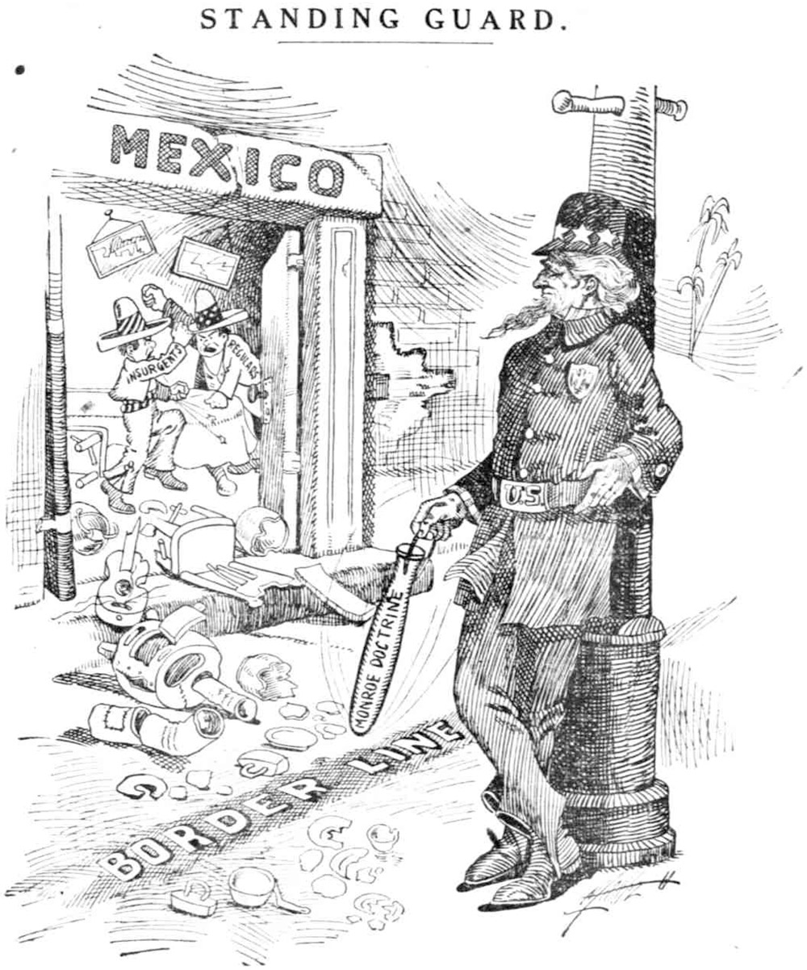
The barbaric actions of the Mexican government have recently made it necessary for United States intervention, specifically the occupation of our troops in the Mexican port of Veracruz. This country is in desperate need of democracy, and the the only people capable of providing them with such a gift is the people of the United States. Under the dictatorship of Porfirio Diaz, for many years the Mexican government had allowed businessmen of the United States to establish a large economic presence in the country. However, in 1910 Diaz was overthrown by an anti-American man known as Francisco Madero. Because the United States had established such a large economic presence in Mexico, though, our president at the time (Taft) knew that Madero’s power was not in the best interest for the United States and therefore that he needed to be removed from power and replaced with a new regime led by Victoriano Huerta. Huerta’s government decided that the only way to remove Madero from power was to brutally murder him, and it was this corrupt act that led our current president Wilson to decide that the United States would not recognize Huerta’s government of butchers. These military dictatorships in Mexico have not provided Mexicans with any morals or knowledge that would allow them to democratically elect a strong and fair leader, so it has become the responsibility of the United States to enlighten the Mexicans with democracy and stabilize a country polluted with corruption. We have recently seized the port of Veracruz in response to Huerta’s refusal to show any penance for the unfair arresting of several American sailors in Tampico. Wilson generously helped to liberate Mexico from the oppressive and unjust rule of Huerta by assisting Venustiano Carranza’s rise to power in order to force Huerta to flee from the country. After Carranza came into power, however, the Mexican government still refused to accept the American guidelines for the creation of a new government. In this way we are more than justified to occupy Mexico and force democracy upon them because they obviously do not know what is good for them, therefore it is necessary for us to show them by force what government their country needs in order to remain stable and be able to thrive. We need to help save the citizens of Mexico from their own government, because they simply lack the knowledge and resources to help themselves.

Presidential Commentary
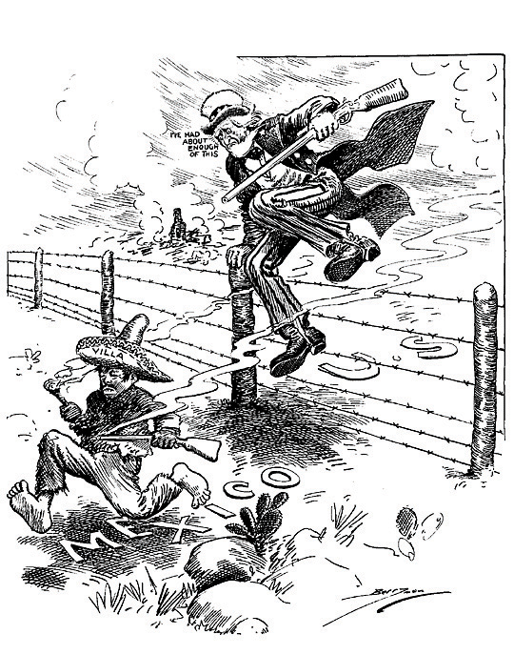
With the United States being the great nation that it is, it was our duty not only to expand, but to educate and civilize those under us. This became evident especially during the war we were involved in with Mexico. The Mexicans became angry towards the United States due to our annexation of Texas, and continued to be reluctant to sell New Mexico and California. The dispatching of John Slidell as a special envoy to persuade the Mexicans in allowing these purchases to pass, and also to reinforce the Mexico-Texas border proved to only have angered them more. Every action we took as a country in resolving issues with our Mexican neighbors resulted in a negative response. All of our efforts to aid them in improving their society were turned down, and a group of people as ungrateful as the Mexicans certainly did not deserve to have the rights to territories which our nation cherished and treated in a more civilized, democratic manner than the Mexicans ever would have. Not only was this our right, citizens of America, but this was our destiny, and we were fully justified in our actions. These actions that our great nation faced in 1846 through 1848 are still relevant today in 1915 with our current conflicts in Mexico. Although I am reluctant to become involved in Imperialism, it is crucial for us to remember that it is for the good of the oppressed Mexican people. The civilizing of their society and their conversion to the wonderful political system of democracy would only aid them in the future. Due to the threat the unstable and undemocratic Mexican government poses to our nation, occupying the port of Veracruz with troops will only lead to good things that will help the nation, and will hopefully allow the Mexicans to realize the benefits of allowing the intervention of the United States in their country.

Woodrow Wilson

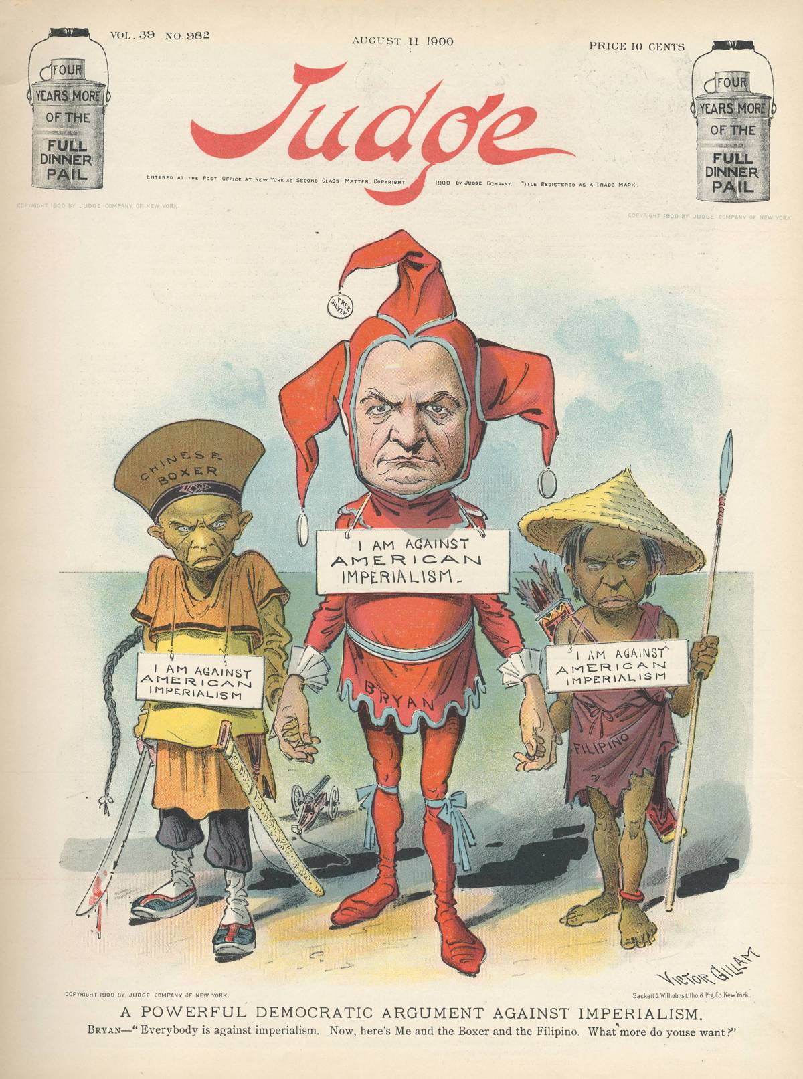
Letter to the Editor
American Imperialism is an awful action that strips the citizens of foreign nations’ natural rights. We take away the right for speech, protest, and many more that we, Americans, fought to protect when we created the United States of America. We are just as bad as Britain was! How can Mr. Wilson try to influence the government to inflict democracy and power upon a country that we have no right to make decisions for. The citizens of Mexico do not need the assistance of America, hence why they have not asked for it. In the siege of Veracruz, the United States initiated war by attacking the Mexican city. Mr. Wilson is incorrect by stating that Mexico was threatening America, they only wanted us out of their nation. America should not be imperializing any nation when it cannot support the people of its own nation. Women and African Americans are still not completely protected by the law of America. Imperialists are unfairly terrorizing the citizens of other nations. They restrict the rights of other people who share the same ideals as Americans, that they can become a rich businessman who started with nothing like Horatio Alger describes. They are trying to create their own society’s government so that they can rule their people justly. They are committing no crime, only America is.
Sincerely, Anonymous

