The Imperialist Inquirer
No. 2369.
Price: 2 cents

Annapolis, Thursday, February 6, 1902. – 3 pages
BRAVE AMERICANS FIGHT OFF REBELS, HELP TO CIVILIZE FILIPINOS

WASHINGTON, FEBRUARY 6. – Three years ago today, our great (but sadly now passed) President William McKinley, in one of the wisest moves of his presidency, helped push through a treaty ensuring American annexation of the set of Asian islands called the Philippines. We had recently engaged in the Spanish-American war designed to free Cuba from oppressive Spanish rule, and the Philippines came as part of the bargain in a $20 million purchase – the great George Dewey, Admiral of the Navy, had obtained them in the Battle of Manila Bay, a heroic feat that will never be forgotten and demonstrates just how exceptional America is. As our great President deduced, since we already possessed the islands, we could not in good faith return them to Spain nor give them to any of the other European powers, as this would be cowardly and irresponsible. Nor could we grant freedom to the natives of the island, who of course were in no position to rule themselves. The only thing we could do, as McKinley put it, was “to take them all and to educate the Filipinos, and uplift and Christianize them, and by God’s grace do the very best we could do by them.”
And that is what we have done. We have brought the great religion of Christianity to the natives, and, with the Education Act of 1901, they have acquired willing teachers to civilize them: I have heard, as of late, of as many as 80 former soldiers that have agreed to help uplift the Filipinos. What noble work! These so-called Thomasites have taught the Filipinos new techniques of agriculture, the English language and grammar, mathematics, and technological feats that awed each and every one of them into becoming good God-fearing Christians.
Not only did we help establish a democratic

free government that gave civilization to the natives of the Philippines, most of whom have nothing but gratitude for our timely intervention, but our annexation of the Philippines was also a wise decision economically. As many of my colleagues argued from the beginning, the Philippines were a stepping-stone to China, which has been a lucrative venture in all respects. It was not right that other European countries reaped the rewards of China while we were excluded from the treasure, and our annexation of the Philippines allowed us to join in, bolstering our economy and helping American industry both in China and back at home. Truly, our taking of the Philippines was a boon for both the natives of the islands and for us.
Finally, with regard to the criticisms of our conduct concerning the suppression the rebels in the Philippines, I would stress that this Emilio Aguinaldo and his cohorts are not the legitimate government of the Philippines: they know little to nothing about governing a people and rather are insurgents contrarian in nature who have slaughtered countless Americans for a cause that their own people does not even agree with. We Americans have only done what we must for the betterment of the people: suppress these rebels and continue our program of education and civilization in the islands.
And, most fortunately, I have recently heard that Aguinaldo has been taken into custody and we can expect an end to this silly rebellion soon: the Philippines will soon be retained and so will our reputation as a great imperialist nation and mother country who nurtures the rest of the world with her infinite wisdom and kindness.

– Elwell Stephen Otis, General of the American Forces in the Philippines

The Imperialist Inquirer

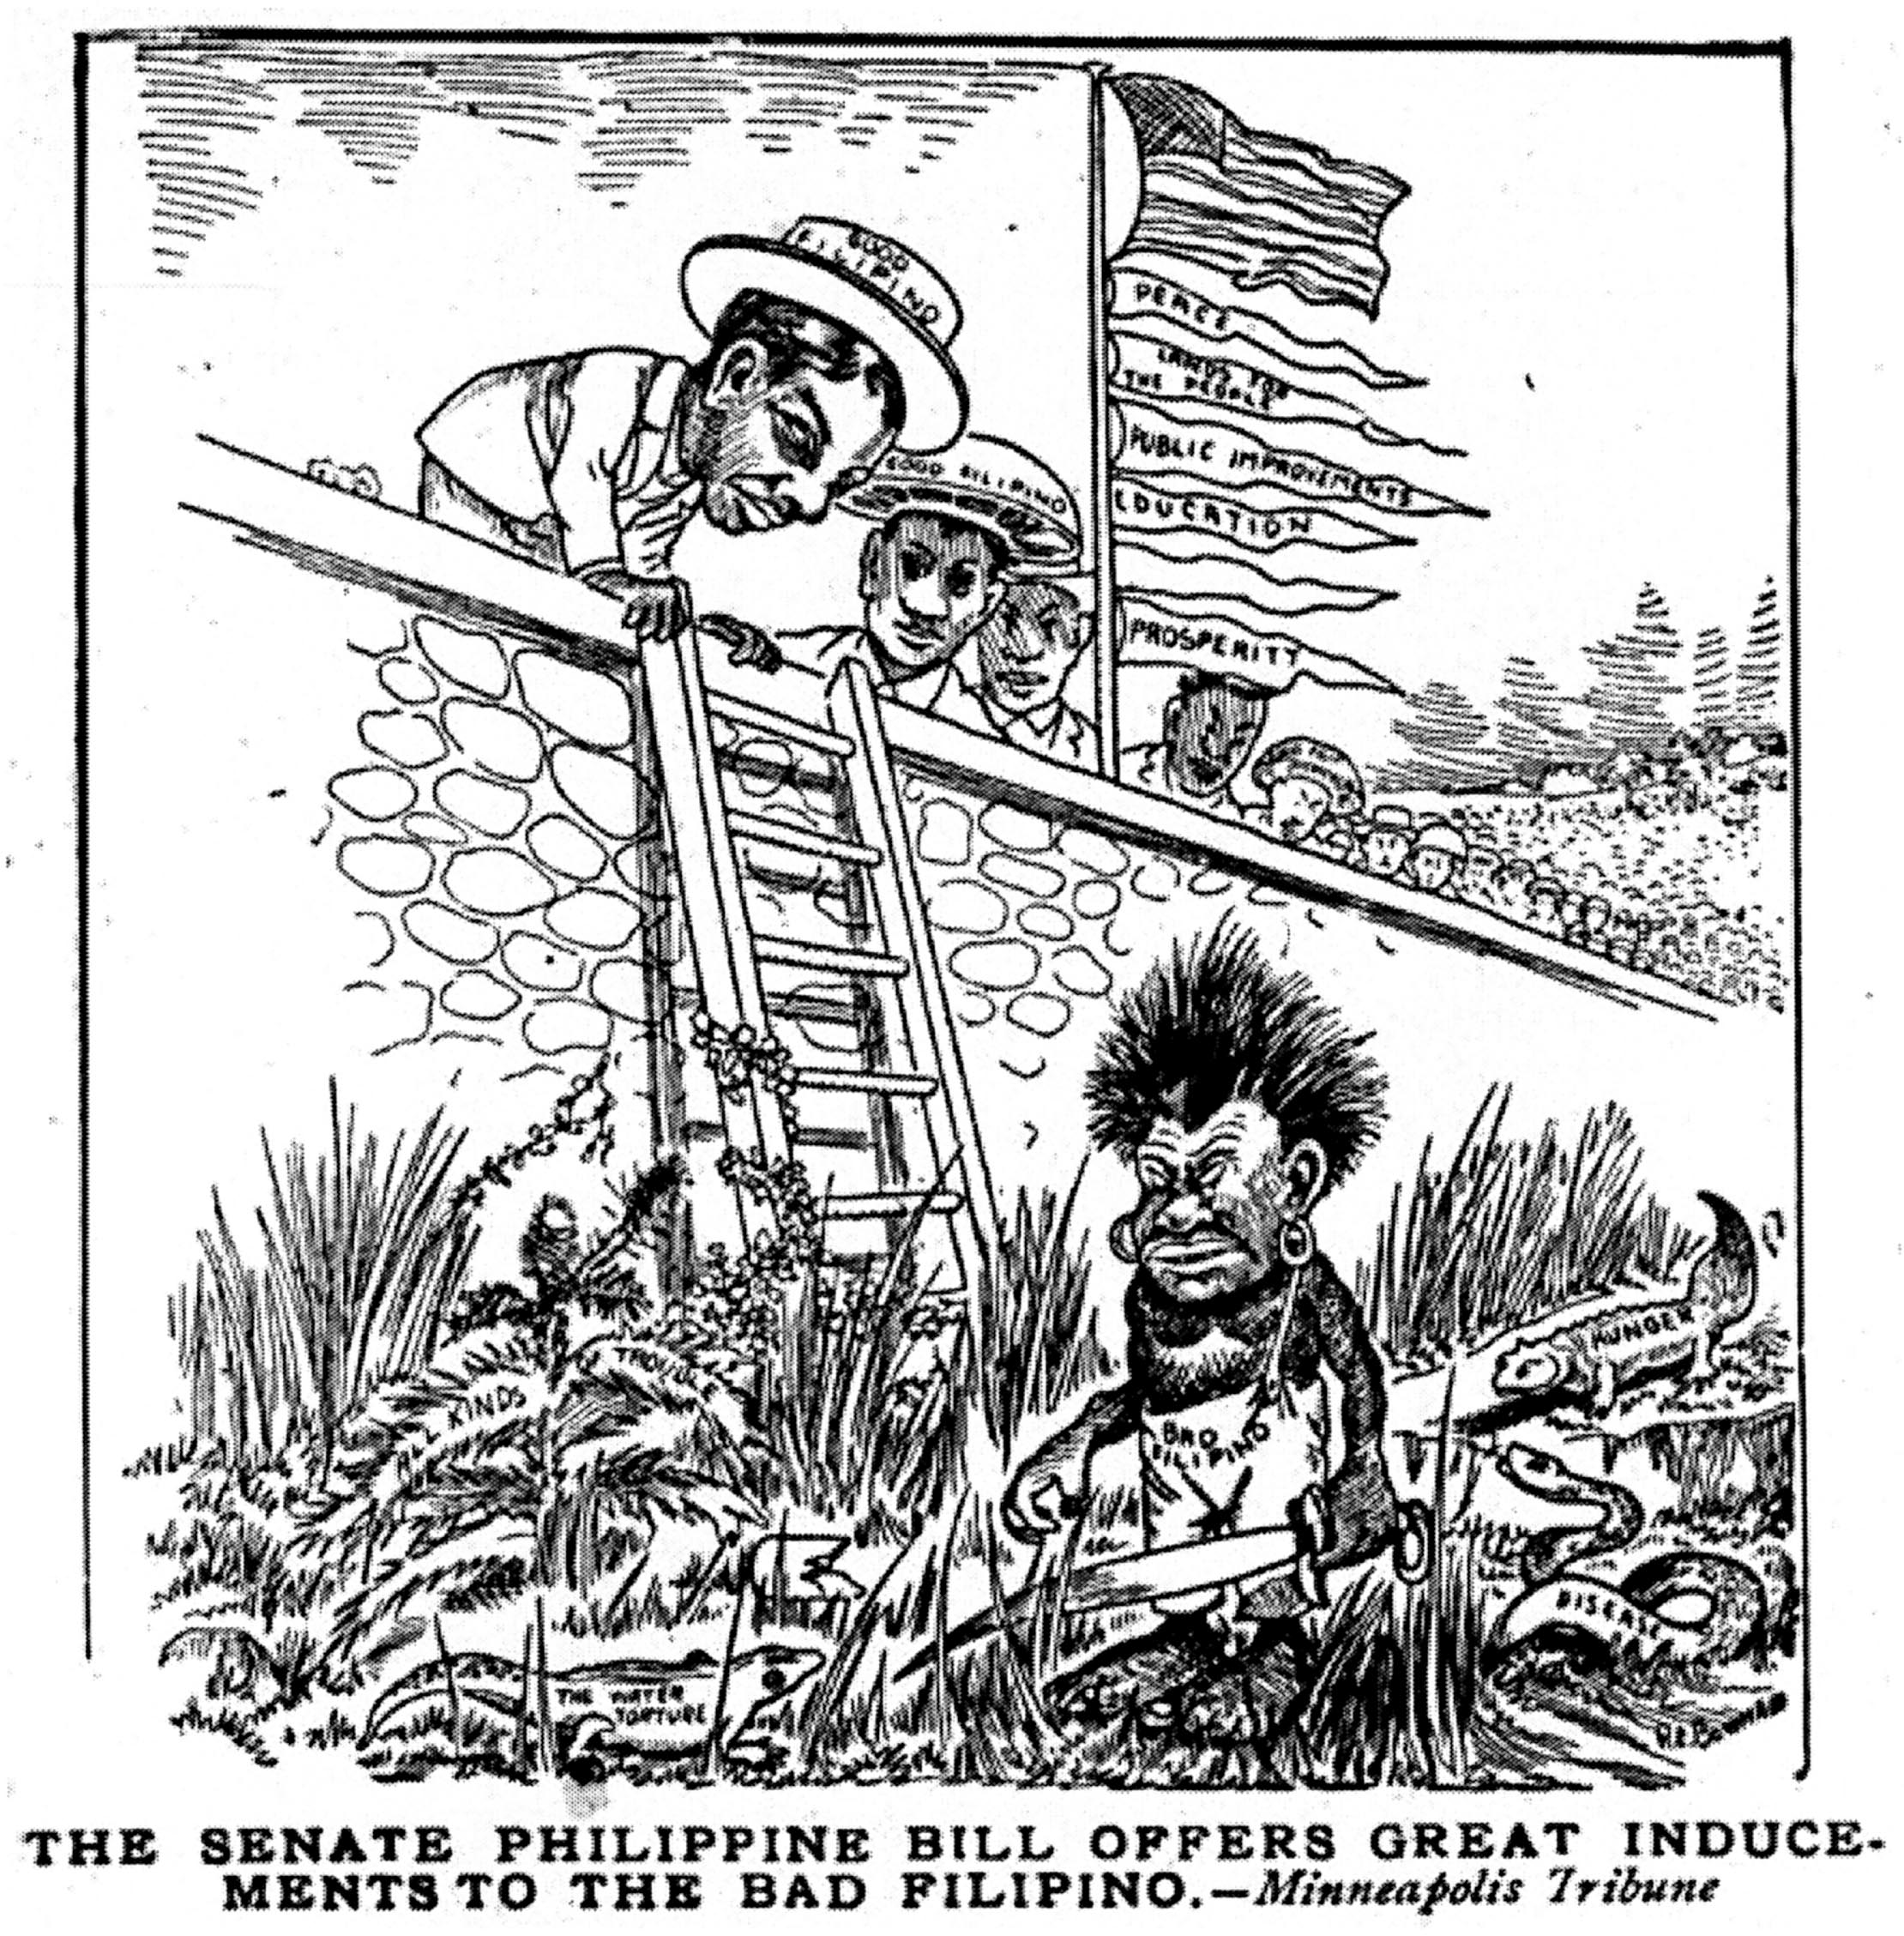

The Imperialist Inquirer

Letter to the Editor
Dear Mr. Otis,

Our involvement in the Philippines is neither a boon to its people nor to us, as you so claim. There is no justification for such intervention in a foreign country, first and foremost because it does not benefit us. It requires us to be involved in foreign affairs, to be entangled in alliances and to maintain a strong army, all of which require us to take a more active role in a world that is volatile and dangerous and one that America need not take a part in. These new territories also threaten our economic prosperity because of the possibility of undercutting and of competition in agriculture and in other industries from the newly acquired islands.
However, the more pressing point, in my mind, is the absolute repudiation of American values that this annexation represents. We claim to hold freedom and self-government dear, but apparently these values only hold when applied to American citizens, not to these Filipinos who have made it abundantly clear that they want self-government and that they are more than capable of it. One need not look further than Aguinaldo’s Declaration of Independence, molded after our own, and the Republic and he and his fellow Filipinos have established to see that these people are more than capable of governing themselves: they know the islands, they know the problems, they know the wants and needs of the people: why should they not be governing themselves? Our blind annexation of them is the result of wanton imperialist and business ambition, not of some far-fetched mission to uplift a people who have acted more civilized throughout the whole affair than we have, and we should recognize and rectify this.
Finally, I would like to point out how ridiculous your claim that our suppression of Aguinaldo and his people is somehow in the best interest of the Philippines. We are the ones who started this war; we are the ones who have killed almost 100,000 natives; we are the ones who use extensive interrogation techniques and torture on innocent prisoners; we are the ones who have executed or burned entire communities. I have even heard tales of some American(!) commanders ordering their troops “to kill and burn, the more you kill and burn the better it will please me. Shoot everyone over the age of 10.” And there is no evidence to say that most Filipinos do not support Aguinaldo; on the contrary, even your own colleague, General MacArthur, admitted that “the Filipino masses are loyal to Aguinaldo and the government which he heads.” Thus, not only are we slaughtering these people, we are slaughtering those people that are representative of the larger population: we are suppressing an entire culture in the name of our own imperialist ambition!
So, with our blatant violations of human rights and our suppression of a rightfully established government in mind, in the name of all that is good and holy, let them be free!

Sincerely,
Mark Twain

(Note from the editor: we in no way agree with or endorse this anti-American, anti-Imperialist opinion: but we were compelled for the sake of fairness to include both sides.)

