APUSH D Block
Mr. Bedar

Unit Guide: Post-1945 America
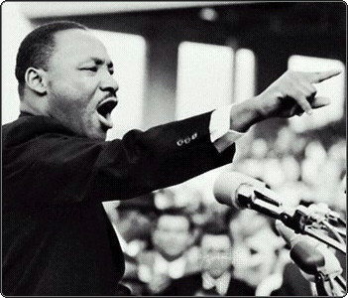
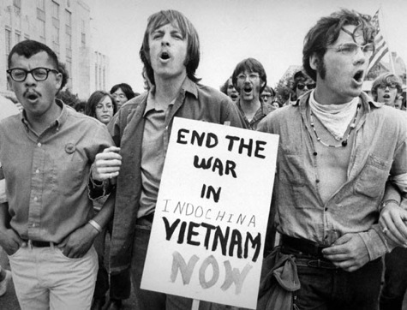
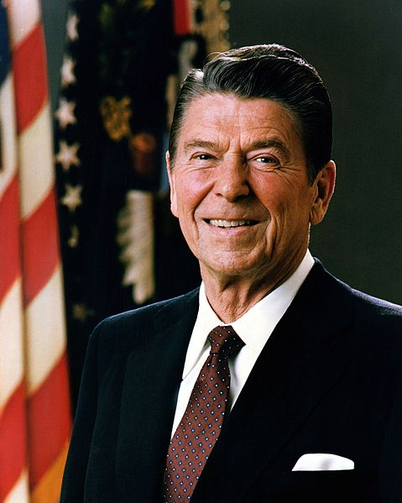
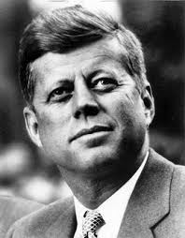

Essential Questions:
- Why did the Cold War begin and how did it influence the US at home and abroad?
- What were the tactics and achievements of the civil rights movement?
- Why did the US enter the Vietnam War and how did that experience change the country?
- What factors led to the “Reagan Revolution” and how has that movement changed the country?

Study Questions
- How did World War II, and its lessons, influence the development of strategic policy in the Cold War?
- What were the causes of the Cold War?
- Why did the US pursue containment?
- How was containment tested in Korea? To what extent was the Korean War a “victory” for the US?
- What led to the creation of an atmosphere of fear in the 1950s? How did this atmosphere create a “culture of conformity”?
- What were the causes and consequences of the US policy towards Cuba during the Cold War?
- What happened during the Cuban Missile Crisis?
- To what extent did US leaders make wise decisions during the Cold War?
- What events led to the beginning of a nationwide civil rights movement in the 1950s?
- What were the tactics used in the civil rights movement?
- What were the major turning points in the civil rights movement?
- How was the message of Malcolm X different from that of Martin Luther King?
- What was the Black Power movement and how was it different from the earlier civil rights movement?
- In what ways was the civil rights movement successful? In what ways was it unsuccessful?
- What led the US to intervene in Vietnam, and why did it escalate its presence in the mid-1960s?
- How did the media and new technology change the way the American public experienced the Vietnam War?
- How did My Lai force the US to consider the ethics of war?
- Why was the US ultimately unsuccessful in Vietnam?
- How successful were the protest movements of the 1960s?
- What major policies were part of LBJ’s Great Society? To what extent was the Great Society successful?
- How did the growing protest movement and Watergate lead to a widespread loss in faith in the government?
- How did conservative Republicans want to change the US after the 1960s?
- What were the problems facing the US in the 1970s that led to the “70s malaise”?
- How did the policies of Ronald Reagan change the country in the 1980s?
- How does the Clinton administration illustrate the success of the Reagan Revolution?
- Why did the Cold War end?
- How did the role of the US in the world change after the end of the Cold War?

