11 American Studies F Block
Mr. Bedar

Unit Syllabus: The Progressive Era, Imperialism, and WWI (2015)

Essential Questions:

- How did the Progressive Era redefine the role of government in the United States? What Gilded Age problems did Progressives seek to address?

- Why did the United States become an imperialist power at the turn of the century?

- What does the Spanish American War reveal about American imperialism?

- How does the American experience in World War I illustrate the main debate over American involvement with the rest of the world?

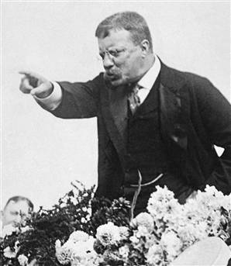

ID Terms:
Read each assignment carefully & identify the ID terms below in your own words. These will serve as excellent study tools. For each ID term, make sure you are able to A) define/describe (who/what/when/where) and B) explain why it is historically significant.
Reading/Topic | Date Due | ID Terms
Chapter 17 Section 1: The Drive for Reform |  | Progressivism  Muckrakers  The Jungle  Triangle Shirtwaist Fire | Initiative  Referendum  Recall  17th Amendment
Chapter 17 Section 4: Roosevelt’s Square Deal (p. 569-575) |  | Theodore Roosevelt  Square Deal  “Trustbusting” | TR’s conservation policies  Types of new regulations
Chapter 17 Section 5: Wilson’s New Freedom (p. 577-579) |  | Woodrow Wilson  16th Amendment  Federal Reserve | Progressivism’s “lasting legacy”  Workers’ rights legislation
Chapter 18 Section 2: The Spanish-American War (p. 592-598) |  | Causes of Sp.-Am War“  Yellow journalism”  jingoism | Pro & anti-imperialist arguments  Results of Sp-Am War
Chapter 19 Section 2: The Home Front (p. 628-635) |  | Selective Service Act  “War economy”  C.P.I.  Feminism during WWI | Espionage & Sedition Acts  Great Migration  Schenck v. United States
Chapter 19 Section 3: Wilson, War, and Peace (p. 641-646 ONLY) |  | Fourteen Points  Self-determination  League of Nations | Henry Cabot Lodge  Why U.S. Senate rejected  the Versailles Treaty

