AP U.S. History  
Bedar

**Imperialism Assignment**

**Assignment:**

You are the much-admired and respected editor of a major national newspaper known for its journalistic integrity and its commitment to telling the truth, the whole truth, and nothing but the truth. Unfortunately, the sensational stories of Pulitzer and Heart are outselling yours. Your task is to outdo them (and also teach the class something about what the U.S. did in each of these areas)

**Directions:**

You are to create the (electronic) front page of your own newspaper in the yellow journalist style of Hearst & Pulitzer, addresssing one of the major areas of American imperialism.

1. **Title of the Newspaper:** Come up with something preferably a little more creative than “Johnny’s Wicked Cool Newspaper.”
2. **The big headline:**  a big, sensational main headline…this will correspond to your BIG story (see #3).
3. **Editorial:** pro-imperialist piece (1 detailed paragraph) that represents your opinion of America’s action in your assigned area. This is an opinion, but it should still be informed by factual evidence. *It will be graded on how specific it is to your assigned country.*
4. **Letter to the Editor:** Another (1 detailed paragraph) opinion anti-imperialist piece that *disagrees* with the above editorial (presents a different interpretation, a contrasting opinion, etc.). Again, this is an opinion, but it should still be informed by factual evidence.
5. **Political cartoon relating to your “thesis” in your (or *make one*, for extra credit!)** If you’re using a “found” cartoon (i.e. one from the internet), find another way to add in some of your own artistry/graphics to the front page. Maps? Important figures? Be creative!

**TOPICS:**

1. **Hawaii, 2) Cuba, 3) Philippines, 4) Puerto Rico, 5) Panama, 6) China, 7) Mexico**

**Grading Rubric:**

1. **Writing Quality**

* Style: Your articles/editorials/letters should reflect the style of Yellow Journalism and provoke thought, opinion, and above all, **interest.** In doing so, they should also be *convincing* and *persuasive*….you’re trying to SELL NEWSPAPERS!
* Technical Prowess: Your articles/editorials/letters should be well-written (free of grammatical & spelling errors, clearly worded, etc.)

1. **Historical Quality (40 points)**

* Factual Evidence: Your front page should incorporate accurate information (the correct names, dates, places, and events)
* Analysis: Your articles/editorials/letters should reflect some analysis, evaluation, and interpretation of events

1. **Graphical Quality (20 points)**

* 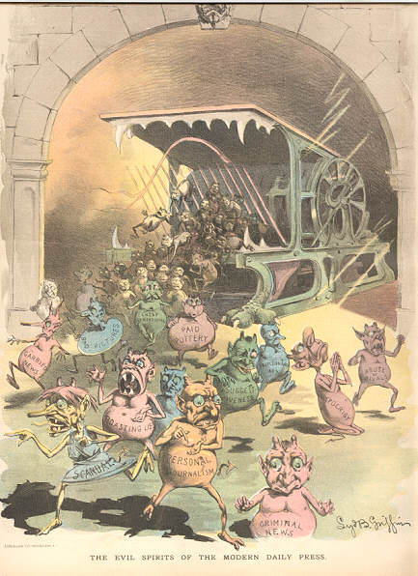 Your front page should be **interesting** to look at (w/ pictures, color, drawings, cartoons, etc)…and stand OUT**!**