11 U.S. History B Block 2014
Mr. Bedar

Unit Syllabus: World War II & Cold War America (The 1940s & 50s)

Essential Questions:
- What led the US to get progressively more involved with WWII?
- How did WWII affect Americans on the homefront?
- What lasting changes did WWII bring to the United States?
- How did the Cold War begin?
- How did the policy of “containment” shape U.S. policy during the Cold War?
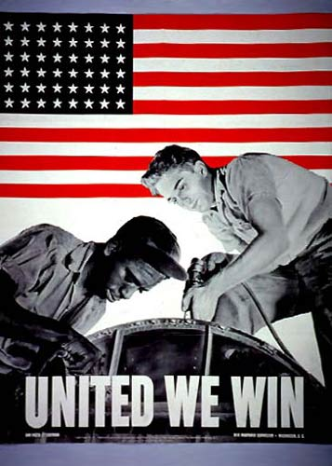
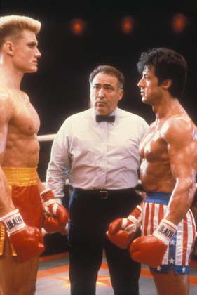
- How did the Cold War affect life at home?

ID Terms:
Read each assignment carefully & identify the ID terms below in your own words. These will serve as excellent study tools. For each ID term, make sure you are able to A) define/describe (who/what/when/where) and B) explain why it is historically significant.
# | Reading/Topic | Date Due | ID Terms
1 | Chapter 23, Section 2: From Isolation to Involvement (p. 779 – 787) |  | Nye Committee  Neutrality Acts  “cash-and-carry”  Isolationist arguments | Interventionist  arguments  Lend-Lease Act  Atlantic Charter
2 | Chapter 24, Section 2: “The Home Front” (p.809-815) |  | “Rosie the Riveter”  “Double V” campaign  Bracero program  “Zoot suit riots” | Japanese internment  442nd Regimental  Combat Team  O.W.I.
3 | Chapter 25, Section 1: The Cold War Begins |  | Difference in American/Soviet systems  Satellite states  Iron curtain | Truman Doctrine  Marshall Plan  Berlin Airlift  NATO & Warsaw Pact
4 | Chapter 25, Section 4: The Cold War at Home (p. 866-875) |  | Red Scare  HUAC  “Hollywood Ten”  Blacklist | Alger Hiss  Rosenbergs  Joseph McCarthy
5 | Chapter 26, Section 2: A Society on the Move (p. 888-895) |  | Suburbs  “Levittowns”  “Car culture”  Interstate Highway Act  Sunbelt | White-collar workers  Franchise business  Multinational corporations  AFL-CIO  Sputnik
6 | Chapter 26, Section 3: Mass Culture and Family Life (p. 896-901) |  | Consumerism  Nuclear family  TV culture | Rock-and-roll  Elvis Presley

